

Hall Booking and Management System

S.F SAFIYA

KUR/IT/2324/F/0080

HNDIT 2026

Hall Booking and Management System

PROJECT REPORT PRESENTED BY

S.F SAFIYA

KUR/IT/2324/F/0080

HIGHER NATIONAL DIPLOMA IN INFORMATION TECHNOLOGY
Of the

ADVANCED TECHNOLOGICAL INSTITUTE – KURUNEGALA
SRI LANKA INSTITUTE OF ADVANCED TECHNOLOGICAL EDUCATION (SLIATE)

2026

DECLARATION

I hereby declare that this project report, Hall Booking & Management System, is entirely my own work and has been carried out under the supervision of Ms. P.G.R.N.J. Gamlath. This project has not been submitted, either in whole or in part, for any other academic award or qualification.
I further declare that all sources of information, ideas, and materials obtained from books, journals, websites, and other references have been appropriately acknowledged and cited in this report. Any assistance received during the development of this project has also been duly acknowledged.
This report is submitted in partial fulfillment of the requirements for the Higher National Diploma in Information Technology (HNDIT) at the Sri Lanka Institute of Advanced Technological Education (SLIATE). No part of this report may be reproduced, stored, or transmitted in any form or by any means without the prior written permission of the author.
Signature of Candidate: ..................................................
Name: S.F. Fathima Safiya
Registration Number: ..................................................
Date: ..................................................
Certified by:
Supervisor Name: Ms. P.G.R.N.J. Gamlath
Signature: ..................................................
Date: ..................................................

ACKNOWLEDGEMENT

I would like to express my sincere gratitude to my supervisor, Ms. P.G.R.N.J. Gamlath, for the continuous guidance, patience and constructive feedback that were given to me throughout the development of this project. Their advice on structuring the booking workflow, reviewing each milestone and questioning my design decisions helped me stay focused on building a system that satisfies both academic requirements and real business needs, rather than a system that only looks good on the surface.
I am also thankful to the management and staff of Camilla Banquet Hotel, who patiently explained how their booking and payment processes are currently handled using physical ledgers, phone calls and manual receipts. The time they spent describing their daily operations, their common problems with double bookings and their method of collecting advance payments became the foundation for almost every business rule that is implemented inside HallCamilla today. Without this information, the system would have been built on assumptions instead of real operational needs.
My appreciation also goes to the technical mentors and fellow students who reviewed early versions of the system architecture with me, particularly the parts related to Firebase Authentication, Cloud Firestore data modelling and the integration of the PayHere Sandbox payment gateway. Their comments helped me identify weaknesses in my original design, such as how payment records should be linked back to bookings, and encouraged me to correct these issues before the final submission.
Finally, I would like to thank my family and friends for their patience, understanding and encouragement during the long hours that were spent designing, coding, testing and documenting this project. Their support made it possible for me to complete this work to the standard required for this final report.

ABSTRACT

The hospitality and event management industry increasingly relies on digital solutions to efficiently manage bookings, payments, and customer communication. However, many banquet halls still depend on manual, paper-based reservation systems, which often lead to problems such as double bookings, misplaced records, payment errors, and difficulty in tracking reservation information. Customers also have limited access to booking updates, requiring them to contact the hotel directly for information.
To address these challenges, HallCamilla was developed as a centralized, cloud-based web application for Camilla Banquet Hotel. The system automates the complete hall booking process, from customer reservation requests and administrative approval to payment management and event completion. It was developed using React, TypeScript, Tailwind CSS, Firebase Authentication, Cloud Firestore, EmailJS, and the PayHere Sandbox payment gateway to provide a secure, responsive, and user-friendly booking platform.
The application features a role-based authentication system that separates customer and administrator functionalities. Customers can browse halls, check availability, calculate event costs, submit booking requests, make online payments, and monitor their booking status. Administrators can manage halls, packages, bookings, payments, customers, reviews, notifications, and reports through a centralized dashboard. The system also performs real-time availability validation to prevent double bookings and supports a hybrid payment process by allowing customers to pay a 20% advance payment online while the remaining balance can be paid online or recorded as an offline cash payment.
Overall, HallCamilla provides a complete digital solution for banquet hall management by reducing paperwork, improving booking accuracy, preventing scheduling conflicts, and enhancing communication through real-time notifications and automated email updates. The system improves operational efficiency while providing customers with a modern, convenient, and transparent online booking experience.

TABLE OF CONTENTS

DECLARATION 3
ACKNOWLEDGEMENT 4
ABSTRACT 5
TABLE OF CONTENTS 6
TABLE OF FIGURES 8
LIST OF TABLES 10
LIST OF ABBREVIATIONS 11
CHAPTER 1 : INTRODUCTION 13
1.1 Purpose 13
1.2 System Overview 13
1.3 Problem Statement 14
1.4 Goals & Vision 15
CHAPTER 2 : REQUIREMENT SPECIFICATION 17
2.1 Requirement Gathering Process 17
2.2 System Functions 17
2.3 Software Requirements 19
2.4 Hardware Requirements 20
CHAPTER 3 : DESIGN 21
3.1 Front-End Design (User Interfaces) 21
3.2 Database Design 52
3.3 Architectural Design 56
CHAPTER 4 : IMPLEMENTATION 63
4.1 Development Approach 63
4.2 Implementation of Key Modules 63
4.3 Challenges Faced 65
CHAPTER 5 : TESTING 66
5.1 Testing Approach 66
5.2 Test Cases 67
5.3 User Acceptance Testing Summary 68
CHAPTER 6 : RESULTS AND EVALUATION 69
6.1 Achievement of Objectives 69
6.2 Limitations 69
CHAPTER 7 : CONCLUSION AND FUTURE WORK 71
7.1 Conclusion 71
7.2 Future Work 72
APPENDICES 73
Appendix A: List of Abbreviations 73
REFERENCES 74

TABLE OF FIGURES

Figure 3. 1: Home Page 21
Figure 3. 2: Hall Catalog Page 22
Figure 3. 3 : Hall Details Page 23
Figure 3. 4 : Budget Calculator Page 24
Figure 3. 5 : Sign In Page 25
Figure 3. 6 : Registration Page 26
Figure 3. 7 : Forgot Password Page 27
Figure 3. 8 : Customer Dashboard Page 28
Figure 3. 9 : Customer Profile Page 29
Figure 3. 10 : Wishlist Page 30
Figure 3. 11 : Event Customization Page 31
Figure 3. 12 : Booking Review & Checkout Page 32
Figure 3. 13 : Payment Page 33
Figure 3. 14 : Customer Notifications Page 34
Figure 3. 15 : Automated Email Notification 35
Figure 3. 16 : Customer Review Page 36
Figure 3. 17 : Admin Dashboard Page 37
Figure 3. 18 : Booking Management Page 38
Figure 3. 19 : Hall Management Page 39
Figure 3. 20 : Package Management Page 40
Figure 3. 21 : Booking Cancellation Page 41
Figure 3. 22 : Review Management Page 42
Figure 3. 23 : Payment Management Page 43
Figure 3. 24 : Reports & Analytics Page 44
Figure 3. 25 : Customer Management Page 45
Figure 3. 26 : Event Types Management Page 46
Figure 3. 27 : Hall Maintenance Page 47
Figure 3. 28 : Availability Management Page 48
Figure 3. 29 : Notifications Management Page 49
Figure 3. 30 : Admin Settings Page 50
Figure 3. 31 : Entity Relationship Diagram 54
Figure 3. 32 : System Architecture Diagram 56
Figure 3. 33 : Use Case Diagram 57
Figure 3. 34 : Activity Diagram 58
Figure 3. 35 : Sequence Diagram 60

LIST OF TABLES

Table 3. 1 : Firestore Collection Structure and Relationship Mapping 53

Table 5 . 1 : Representative Test Cases 67

Table A . 1 : Abbreviations Used in This Report 73

LIST OF ABBREVIATIONS

The following abbreviations are used throughout this report.
Abbreviation | Meaning
AC | Air Conditioning
API | Application Programming Interface
CRUD | Create, Read, Update, Delete
CSS | Cascading Style Sheets
EmailJS | EmailJS Email Service
ERD | Entity Relationship Diagram
FAQ | Frequently Asked Questions
Firebase | Google Firebase Platform
Firebase Auth | Firebase Authentication
Firestore | Firebase Cloud Firestore
HNDIT | Higher National Diploma in Information Technology
HTML | HyperText Markup Language
HTTPS | HyperText Transfer Protocol Secure
IEEE | Institute of Electrical and Electronics Engineers
JSON | JavaScript Object Notation
JWT | JSON Web Token
KPI | Key Performance Indicator
LKR | Sri Lankan Rupee
NoSQL | Non-Relational Database
Abbreviation | Meaning
PDF | Portable Document Format
REST | Representational State Transfer
SaaS | Software as a Service
SDK | Software Development Kit
SMTP | Simple Mail Transfer Protocol
SPA | Single Page Application
SQA | Software Quality Assurance
SRS | Software Requirements Specification
TS | TypeScript
UAT | User Acceptance Testing
UI | User Interface
UML | Unified Modeling Language
URL | Uniform Resource Locator
UX | User Experience
Vite | Vite Frontend Build Tool
React | React JavaScript Library
Tailwind CSS | Tailwind CSS Framework
PayHere | PayHere Online Payment Gateway

CHAPTER 1 : INTRODUCTION

1.1 Purpose

The primary purpose of the HallCamilla project is to digitally transform the hall booking and management process of Camilla Banquet Hotel by replacing the traditional manual reservation system with a centralized web-based application. The system enables administrators to manage hall reservations, customer information, payments, and booking schedules efficiently while providing customers with real-time hall availability, transparent pricing, and an online booking experience. By storing all booking and payment records in Firebase Cloud Firestore, the system ensures data accuracy, security, and real-time accessibility.
In addition to addressing a real-world business problem, this project also fulfills the academic requirements of the Higher National Diploma in Information Technology (HNDIT) programme. It demonstrates practical knowledge of modern web application development through the use of React, TypeScript, Firebase Authentication, Cloud Firestore, Tailwind CSS, EmailJS, and the PayHere Sandbox payment gateway. The project showcases the ability to independently design, develop, test, and deploy a complete full-stack software solution that meets both functional and non-functional requirements.

1.2 System Overview

HallCamilla is a web-based single-page application consisting of two main modules: the Customer Portal and the Administrator Dashboard. Although both modules share the same application and Cloud Firestore database, the available features are determined by the authenticated user's role. This role-based structure provides customers with a simple booking experience while enabling administrators to efficiently manage the hotel's booking operations.
The Customer Portal allows users to browse available halls and event packages, check hall availability, calculate event costs, customize bookings with additional services, and submit reservation requests. Customers can also manage their profiles, track booking status, make online payments through the PayHere payment gateway, receive notifications, maintain a wishlist, and submit reviews after completed events.
The Administrator Dashboard provides tools for managing halls, packages, bookings, customers, payments, event types, maintenance schedules, reviews, reports, notifications, and system settings. Administrators can approve or reject bookings, update booking and payment statuses, manage venue availability, and monitor business performance through dashboards and reports.
All application data is stored in Firebase Cloud Firestore, while Firebase Authentication provides secure user authentication and role-based access control. Firestore's real-time synchronization ensures that updates made by customers or administrators are immediately reflected throughout the system without requiring manual page refreshes.

1.3 Problem Statement

Camilla Banquet Hotel, like many similar hospitality businesses, has traditionally relied on a fully manual approach for managing hall reservations. New booking enquiries were recorded manually in reservation ledgers, while advance payments and final balances were documented using physical receipts. Although this approach may be sufficient for a small number of events, it becomes increasingly difficult to manage as booking volume grows. These limitations created the primary motivation for developing the HallCamilla system.
The first and most critical issue identified was the risk of double bookings. Since staff members had to manually check physical records whenever a new reservation request was received, there was a possibility of overlooking existing reservations and accidentally accepting multiple events for the same hall and date. Such conflicts, especially when discovered close to the scheduled event date, could negatively impact customer satisfaction, damage the hotel's reputation, and result in financial losses.
The second major issue was related to payment and financial management. Advance payments and remaining balances were calculated manually, which increased the possibility of calculation errors and required additional administrative effort. Furthermore, the absence of a centralized digital record made it difficult for management to obtain accurate and up-to-date information about collected revenue, outstanding payments, and overall booking performance.
The third issue was the lack of transparency and accessibility for customers. Without a digital booking platform, customers were required to contact the hotel through phone calls or physical visits to obtain information about their reservation status or payment history. This created inconvenience for customers while increasing the workload of hotel staff who had to repeatedly respond to similar booking-related enquiries.
HallCamilla was developed to address these challenges through a centralized digital booking and management solution. The risk of double bookings is minimized through automated availability validation, where the booking service checks Cloud Firestore for existing active reservations before allowing a new booking request to proceed. Financial calculations, including the 20% advance payment and 80% remaining balance, are automatically calculated by the system and recorded within the payment management process, reducing manual calculation errors.
Furthermore, customer transparency is improved through the customer dashboard, real-time booking updates, automated email notifications, and in-app notifications. These features allow customers to access accurate information about their booking status and payment progress without needing to directly contact hotel staff, while also improving the efficiency of hotel operations.

1.4 Goals & Vision

The primary goal that guided the development of HallCamilla was to create a reliable, secure, and user-friendly web application capable of managing the complete lifecycle of a banquet hall reservation, from the initial booking request until the final completion of the event. Reliability was achieved by implementing robust availability validation mechanisms that prevent conflicting reservations, security was ensured through role-based access control that restricts administrative operations to authorized users, and usability was addressed by designing an interface that can be effectively used by both administrators and customers with different levels of technical experience.
By the completion of the development period, several key objectives were successfully achieved. A role-based authentication and authorization system was implemented using Firebase Authentication together with a Firestore users collection that stores user roles and access permissions. A hybrid payment management system was also developed, supporting online card transactions through the PayHere Sandbox gateway and manual recording of offline cash payments by administrators. In addition, a real-time database architecture was successfully implemented using Cloud Firestore, allowing important system changes, such as administrator approval of booking requests, to be immediately reflected on customer dashboards without requiring manual page refreshes.
The long-term vision for HallCamilla is to expand the system into a scalable multi-tenant platform capable of supporting multiple banquet properties through a single centralized solution. Future improvements may include vendor and supplier management, customizable catering and service selections during the booking process, and integrated staff scheduling features to support better event resource planning.
Even in its current single-hotel implementation, HallCamilla provides significant operational benefits by reducing manual administrative workload, improving accuracy in financial and booking management, providing real-time visibility of reservation activities, and enhancing the customer experience through a modern digital booking platform. The system transforms the traditional phone-based reservation and paper-based record approach into a more efficient, transparent, and professional online solution.

CHAPTER 2 : REQUIREMENT SPECIFICATION

2.1 Requirement Gathering Process

The requirements for HallCamilla were not taken from a generic template of hotel booking features. Instead, they were identified through a combination of business analysis and direct observation of how a typical banquet hall actually operates on a daily basis. The first step was to study the standard operational procedure that a venue like Camilla Banquet Hotel follows when converting a simple customer enquiry into a confirmed, paid reservation, which includes checking hall availability, discussing package pricing, collecting an advance payment to secure the date and eventually collecting the remaining balance before or on the day of the event.
Alongside this business analysis, particular attention was paid to observing the pain points of the existing manual workflow, especially the physical booking ledger and the handwritten cash receipts that were used to track payments. These observations made it clear that the two biggest sources of frustration for the hotel were the risk of double booking a hall and the difficulty of keeping an accurate running total of how much money had actually been collected for each event. Once these pain points were understood, a functional analysis was carried out to translate each manual step into a corresponding digital action, for example transforming the informal decision of a manager to approve a request into a formal status change from Pending to Approved inside the system, and transforming the manual calculation of a deposit into an automatic twenty percent advance calculation performed by the payment service.
This grounded, observation based approach to requirement gathering was deliberately chosen over simply listing generic hotel software features, because the real goal of the project was to build something that hotel staff would find genuinely useful and intuitive in their actual daily routine, rather than a system that looks impressive on paper but does not match how the business really works.

2.2 System Functions

The HallCamilla system is organized into five main functional modules that work together to provide a complete hall booking and management solution for both customers and administrators. Each module combines React components for the user interface, Firebase Cloud Firestore for data storage, and service files that handle the application's business logic.
The Authentication Module provides secure user registration and login functionality for both customers and administrators. It uses Firebase Authentication to verify user credentials, while the Users collection in Firestore stores profile information and user roles. The module also uses AuthContext to maintain user sessions throughout the application, ensuring that only authorized users can access protected features based on their assigned roles.
The Booking Management Module allows customers to browse available halls, select an event package, choose an event date, specify the number of guests, and submit booking requests. All booking information is stored in the Bookings collection, while the booking service validates availability and prevents conflicting reservations before saving the booking details. This module provides customers with a simple and efficient online reservation experience.
The Booking Administration Module enables administrators to manage all booking requests through the administrative dashboard. Staff can review booking details, approve or reject reservations, update booking statuses, and manage hall availability. Once a booking is approved, the system automatically updates the database and sends a confirmation email to the customer using EmailJS, ensuring that customers receive timely updates regarding their reservations.
The Payment Management Module handles all financial transactions related to hall reservations. Customers can pay the required 20% advance payment online through the PayHere Sandbox payment gateway to confirm their booking, while the remaining balance can either be paid online or recorded manually as a cash payment by an administrator. Payment details are stored in the Payments collection, and the payment service automatically updates the corresponding booking status, ensuring accurate and consistent financial records.
The Notifications Module automatically informs customers and administrators about important system activities. Notifications are generated for events such as new booking requests, booking approvals, payment confirmations, and booking status updates. The module stores notifications in the Notifications collection and displays them through the notification interface, allowing users to receive real-time updates without requiring manual communication.
Together, these five functional modules provide an integrated solution for managing hall bookings, customer information, payments, and administrative tasks. By combining modern web technologies with Firebase's real-time capabilities, HallCamilla delivers a secure, efficient, and user-friendly platform that improves both operational efficiency and customer experience.

2.3 Software Requirements

HallCamilla was developed using a modern JavaScript-based technology stack to ensure high performance, scalability, and maintainability. React was selected as the frontend library because its component-based architecture allows reusable user interface components to be created and shared across both the customer and administrator modules. TypeScript was used to improve code quality by providing static type checking, reducing runtime errors, and making the application easier to maintain as it grows.
The project uses Vite as the build tool due to its fast development server, quick hot module replacement, and optimized production builds. Tailwind CSS was chosen for designing the user interface because its utility-first approach enables rapid development while maintaining a consistent and responsive design throughout the application.
For the backend services, Firebase Authentication and Cloud Firestore were used to provide secure user authentication, role-based access control, and real-time data storage. This Backend-as-a-Service (BaaS) approach eliminates the need for a separate backend server while ensuring secure and reliable data management. React Router manages navigation between the public pages, customer portal, and administrator dashboard, allowing the application to function as a smooth single-page application.
To support online payments, the PayHere Sandbox payment gateway was integrated, enabling customers to make secure advance payments during the booking process. In addition, EmailJS was used to send automated email notifications for booking confirmations and status updates, improving communication between the hotel and its customers.
The development process was supported by Node.js and npm for package management, Git for version control, and Visual Studio Code as the primary development environment. Together, these technologies provide a reliable, secure, and efficient platform for the HallCamilla Booking and Management System.

2.4 Hardware Requirements

HallCamilla is a cloud-based web application, so its hardware requirements are relatively minimal compared to traditional desktop software. Since the system is hosted on Firebase, users do not need to install any additional software or maintain local servers to access the application.
For development purposes, the system requires a computer with a modern multi-core processor, such as an Intel Core i5 or AMD Ryzen 5, at least 8 GB of RAM, and a Solid-State Drive (SSD) with sufficient free storage. These specifications ensure smooth performance while running the Node.js environment, Vite development server, Visual Studio Code, and other development tools simultaneously.
For end users, the hardware requirements are simple. Customers and administrators can access the system using any modern desktop computer, laptop, tablet, or smartphone with a stable internet connection and an up-to-date web browser such as Google Chrome, Mozilla Firefox, Microsoft Edge, or Safari. This flexibility allows customers to browse halls, make bookings, and complete payments from their mobile devices, while administrators can efficiently manage reservations and hotel operations from desktop or laptop computers.
Overall, the cloud-based architecture of HallCamilla minimizes hardware costs, eliminates the need for dedicated server infrastructure, and provides users with convenient access to the system from a wide range of devices.

CHAPTER 3 : DESIGN

3.1 Front-End Design (User Interfaces)

The front end of HallCamilla was designed to reflect the image of a premium hospitality brand rather than a conventional booking system, aligning with the hotel's focus on luxury weddings, birthday celebrations, and corporate events. The user interface follows a Luxury Emerald and Gold theme, where deep emerald green represents elegance, trust, and stability, while gold accents highlight primary actions, pricing information, and important notifications. This colour scheme guides users naturally through the booking process while reinforcing the hotel's brand identity.
Typography combines a classic serif font for headings with a modern sans-serif font for body text and form fields. This approach provides a balance between a sophisticated appearance and readability, ensuring that the interface remains visually appealing while supporting a smooth user experience.
Navigation is provided through a responsive top navigation bar that adapts to both desktop and mobile devices. The system clearly separates customer-facing pages from administrative pages to provide interfaces tailored to each user role. Customer pages emphasize a simple, step-by-step booking workflow, allowing users to easily browse halls, customize events, complete payments, and monitor reservations. In contrast, the administrator pages prioritize operational efficiency through dashboards, data tables, analytical charts, and management tools that support booking administration, payment tracking, reporting, and system maintenance.
The following sections present the implemented user interfaces of the HallCamilla system in the sequence that customers and administrators interact with them during normal system operation.

.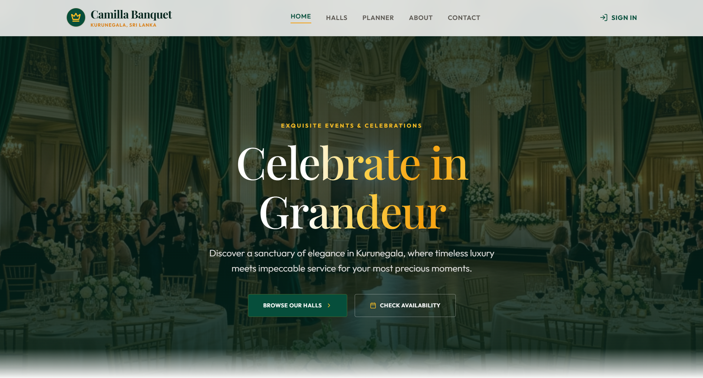
Figure 3. 1: Home Page

The Home Page is the main entry point of the HallCamilla system and provides users with an attractive introduction to the hotel services. It uses a luxury emerald green and gold theme that represents the hotel branding. The page includes a hero banner with clear booking call-to-actions, featured halls, event packages, customer reviews, and important hotel information.
Hall and package details are dynamically retrieved from Firebase Firestore, allowing administrator updates such as pricing, images, and descriptions to be reflected automatically. Navigation links provide quick access to the Hall Catalog, Budget Calculator, Login, and Registration pages.

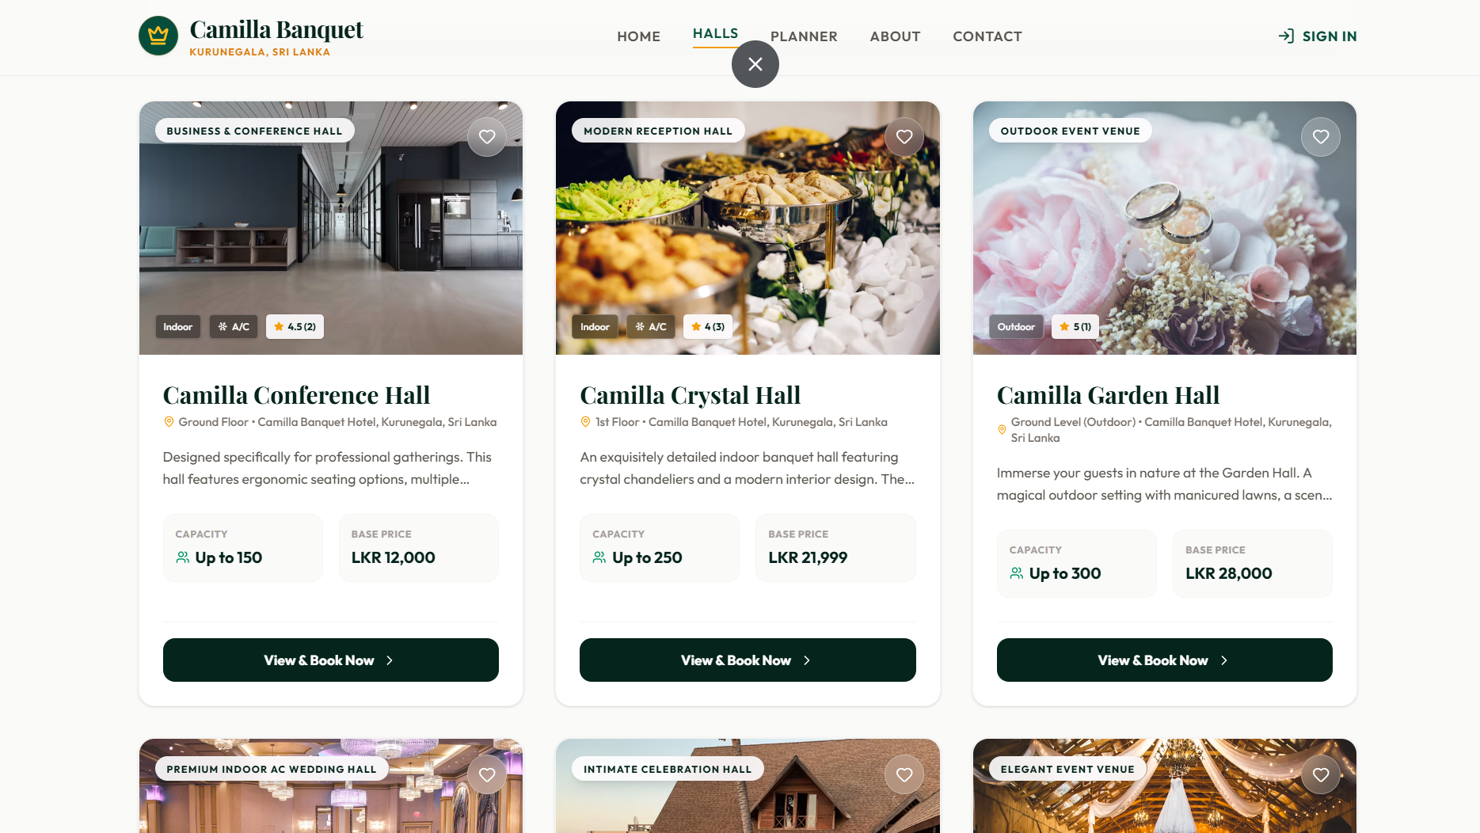
Figure 3. 2: Hall Catalog Page

The Hall Catalog Interface allows users to explore available halls and event packages through an organized card-based layout. Each card displays important details such as hall name, images, starting price, guest capacity, location, and a brief description.
The interface provides search and filtering options to help users find suitable halls based on their event requirements. Hall information is retrieved from Firebase Firestore, ensuring that any updates made by administrators are displayed in real time.

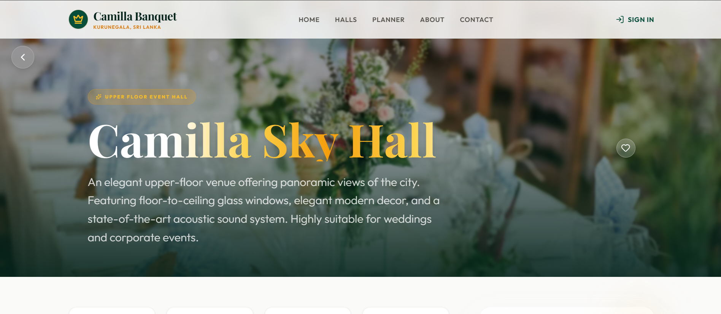
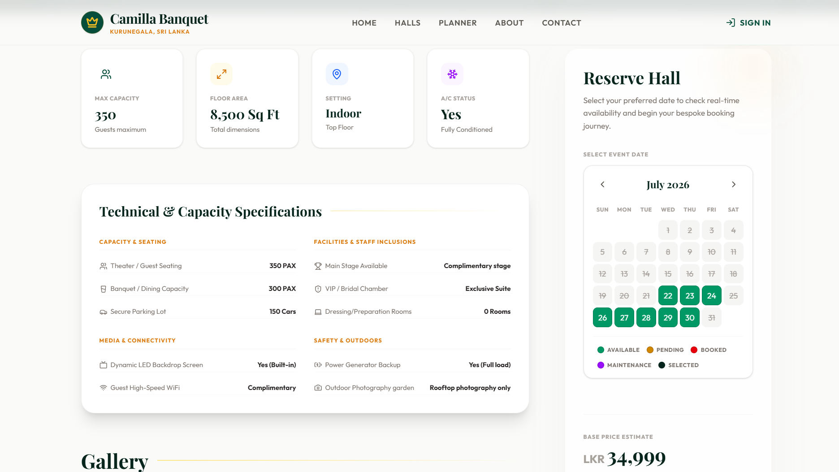
Figure 3. 3 : Hall Details Page

The Hall Details Interface provides detailed information about a selected hall, including image galleries, descriptions, pricing, guest capacity, amenities, and available services.
Users can save preferred halls using the Wishlist feature or proceed with reservations through the Book Now option. The system retrieves hall details dynamically from Firestore using the hall ID provided through the URL.
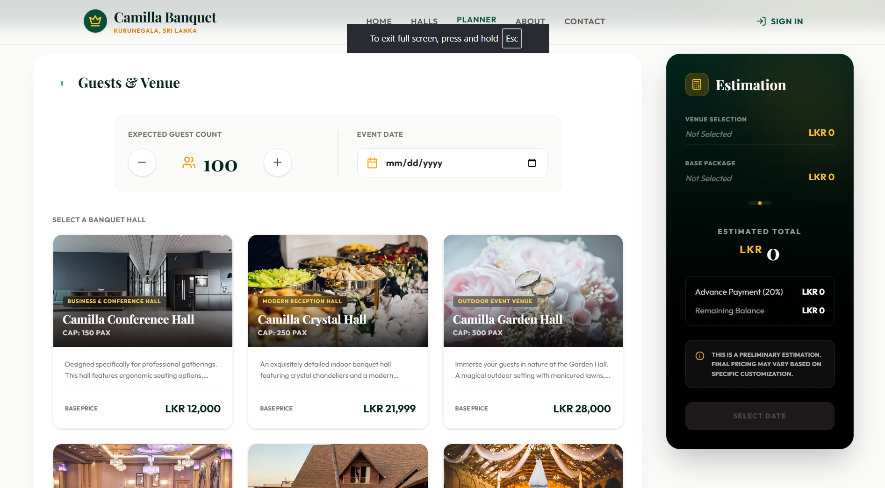
Figure 3. 4 : Budget Calculator Page

The Budget Calculator Interface helps customers estimate their expected event cost before booking. Users can select a hall package, enter the expected guest count, and choose additional services such as photography, catering, and DJ services.
The system performs real-time calculations by combining package prices, guest numbers, and selected service charges. This provides customers with a clear cost estimation and reduces uncertainty about the total booking amount.

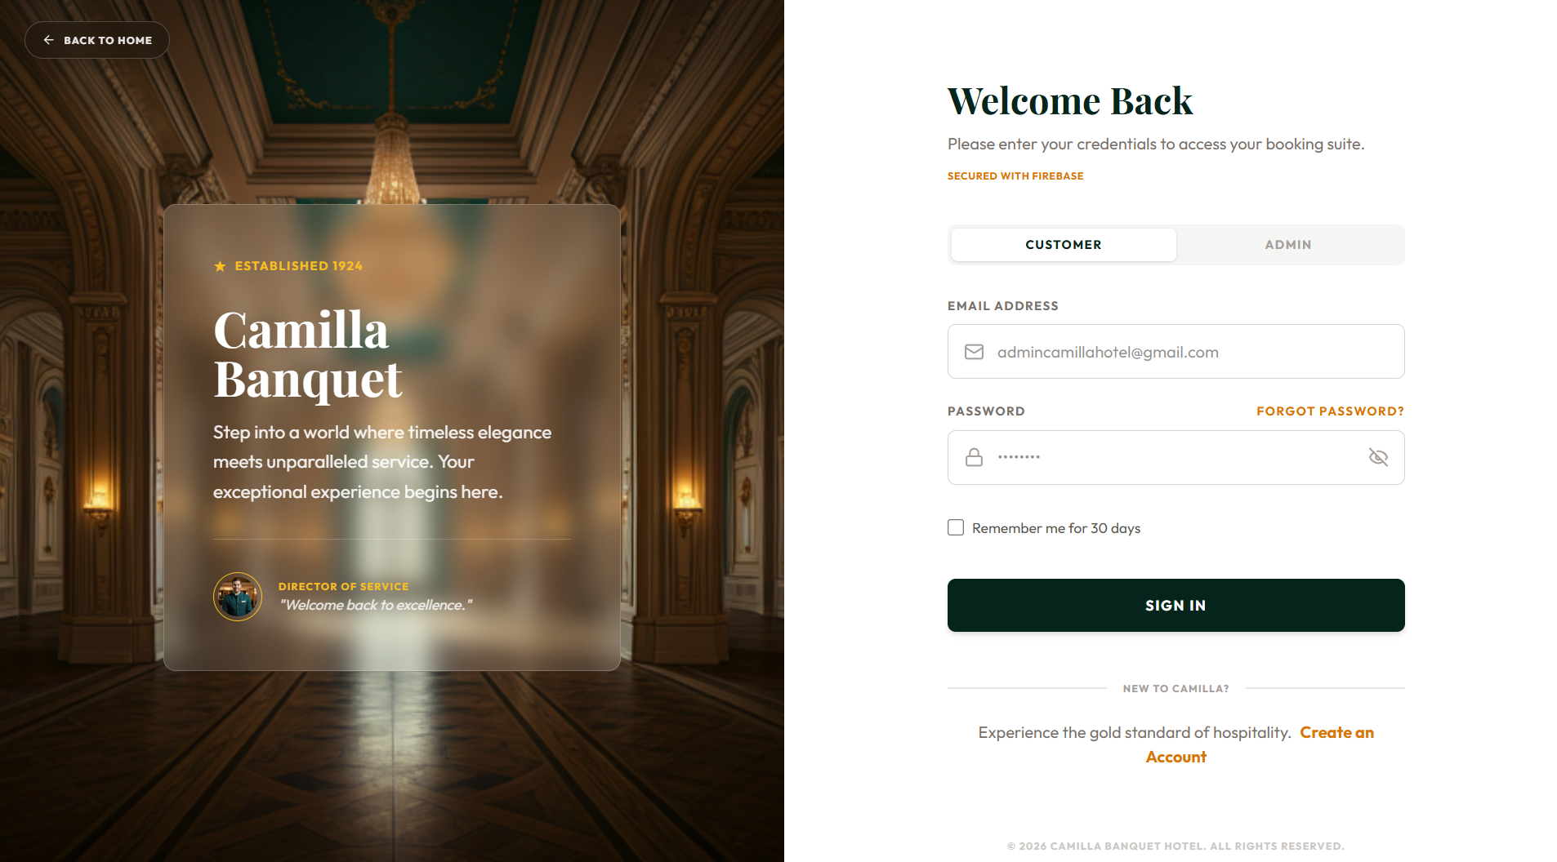
Figure 3. 5 : Sign In Page

The Login Interface provides secure access to the system for both customers and administrators. Users can enter their email and password, with additional options for registration and password recovery.
The system verifies credentials through Firebase Authentication. After successful login, users are redirected to their relevant dashboard based on their assigned role, either Customer or Admin.

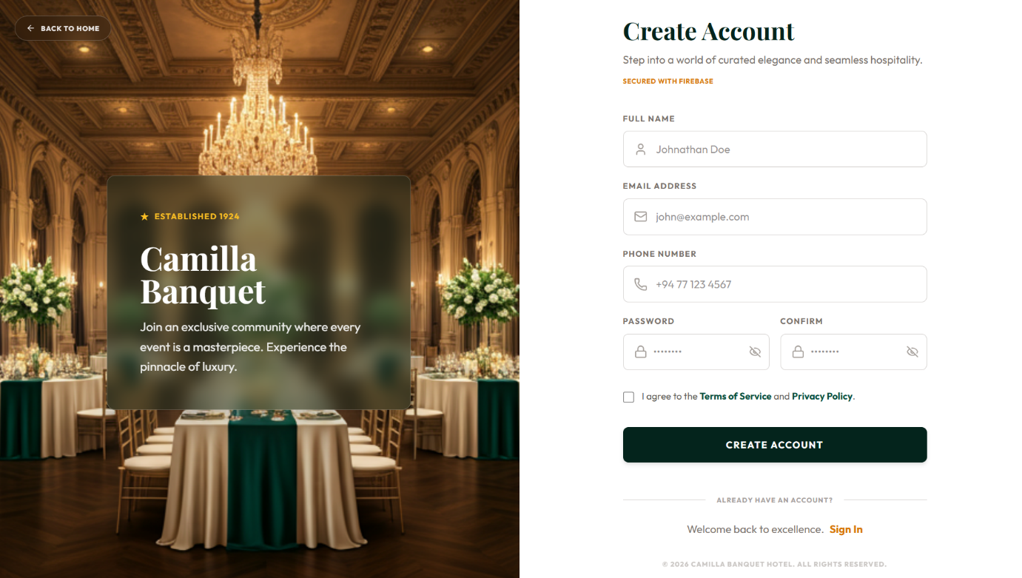
Figure 3. 6 : Registration Page

The Register Interface allows new customers to create an account by entering details such as full name, email address, phone number, and password.
The system validates user inputs before creating the account through Firebase Authentication. After successful registration, customer details are stored in the Firestore users collection with the default Customer role, enabling access to booking features.

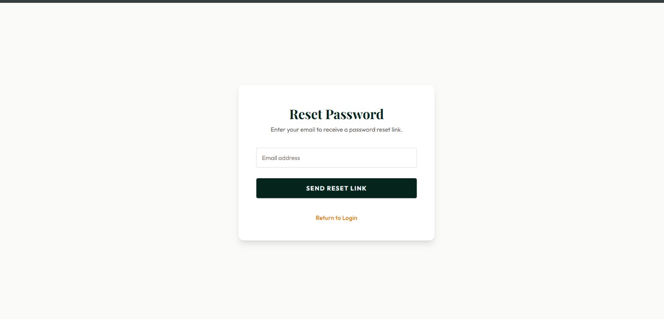
Figure 3. 7 : Forgot Password Page

The Forgot Password Interface provides a secure method for users to recover access to their accounts. Users only need to enter their registered email address to request a password reset.
The system uses the Firebase Authentication password recovery service to generate and send a secure reset link to the user's email, allowing them to update their password without administrator involvement.

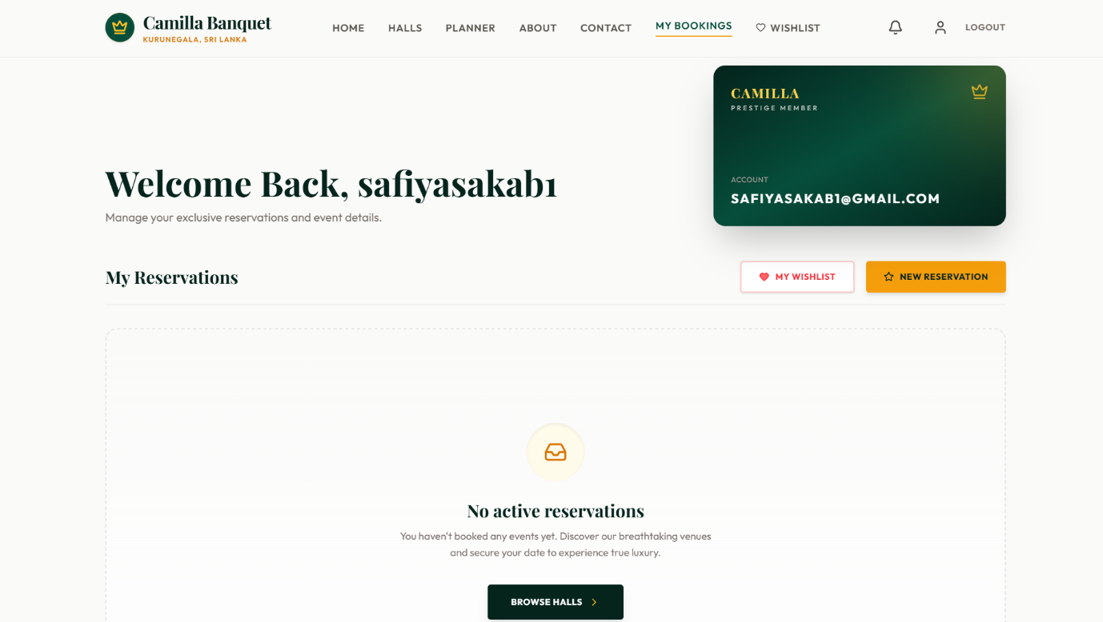
Figure 3. 8 : Customer Dashboard Page

The Customer Dashboard acts as a personal management area where users can monitor their booking activities. It displays summary information such as total bookings, upcoming events, and recent booking history.
Booking details including event dates, hall information, payment status, and reservation status are retrieved from Firestore. User-based filtering ensures that customers can only access their own booking information.

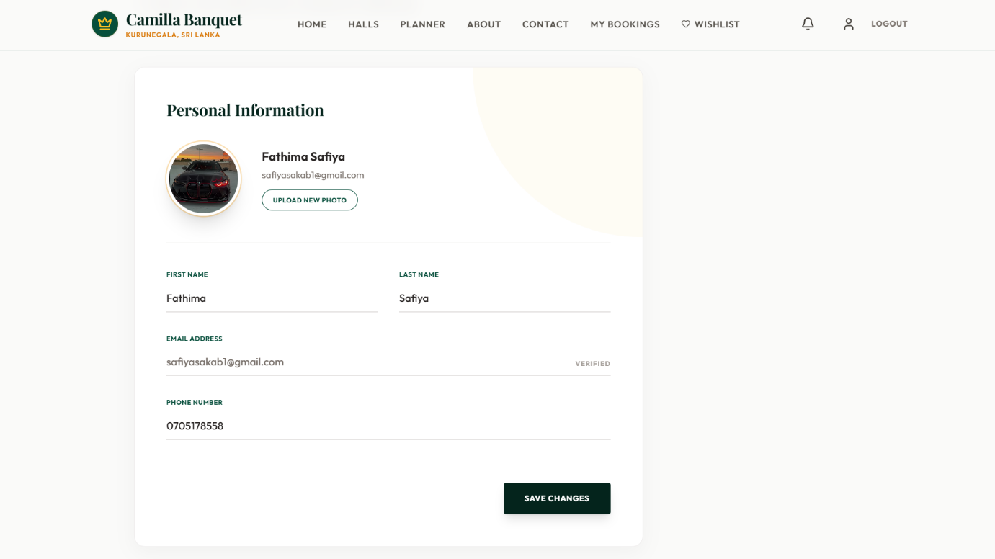
Figure 3. 9 : Customer Profile Page

The Customer Profile Interface allows users to view and update their personal account information, including name, phone number, and billing details.
Updated information is saved to the user's Firestore profile document. These details are used by the system for customer communication, including booking confirmations, notifications, and receipts.

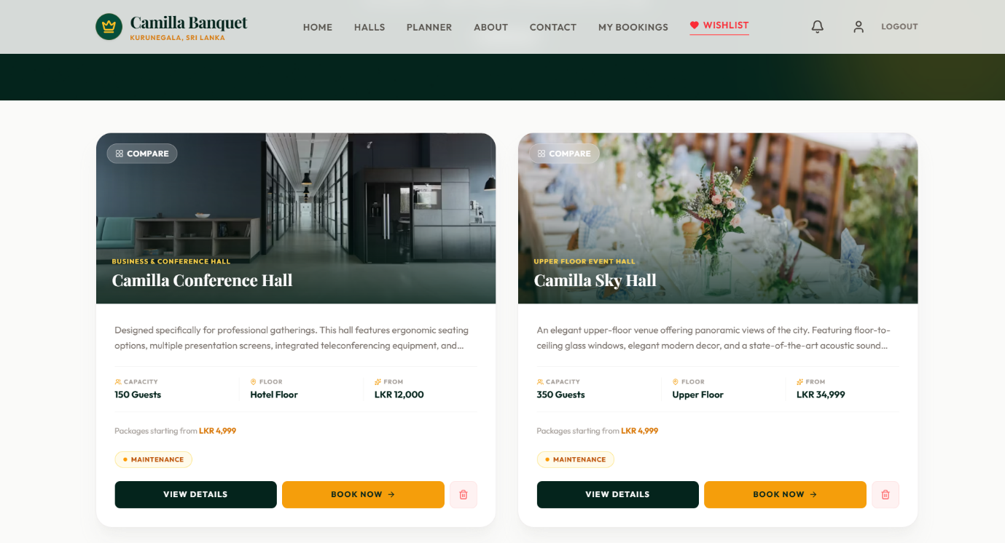
Figure 3. 10 : Wishlist Page

The Wishlist Interface provides customers with a personalized area to save preferred halls and packages for future consideration.
Saved items are stored within the customer's Firestore profile document and displayed in a similar layout to the Hall Catalog. Customers can review saved options, remove unwanted items, or continue to the booking process.



Figure 3. 11 : Event Customization Page

The Customize Your Event Interface allows customers to personalize their booking by selecting additional services before checkout. Users can choose optional services such as photography, DJ services, floral decorations, and catering through interactive service cards.
The interface dynamically updates the selected services and recalculates the estimated total cost based on customer choices. The final selected service details are passed to the checkout process, providing customers with better control over their event customization and budget.

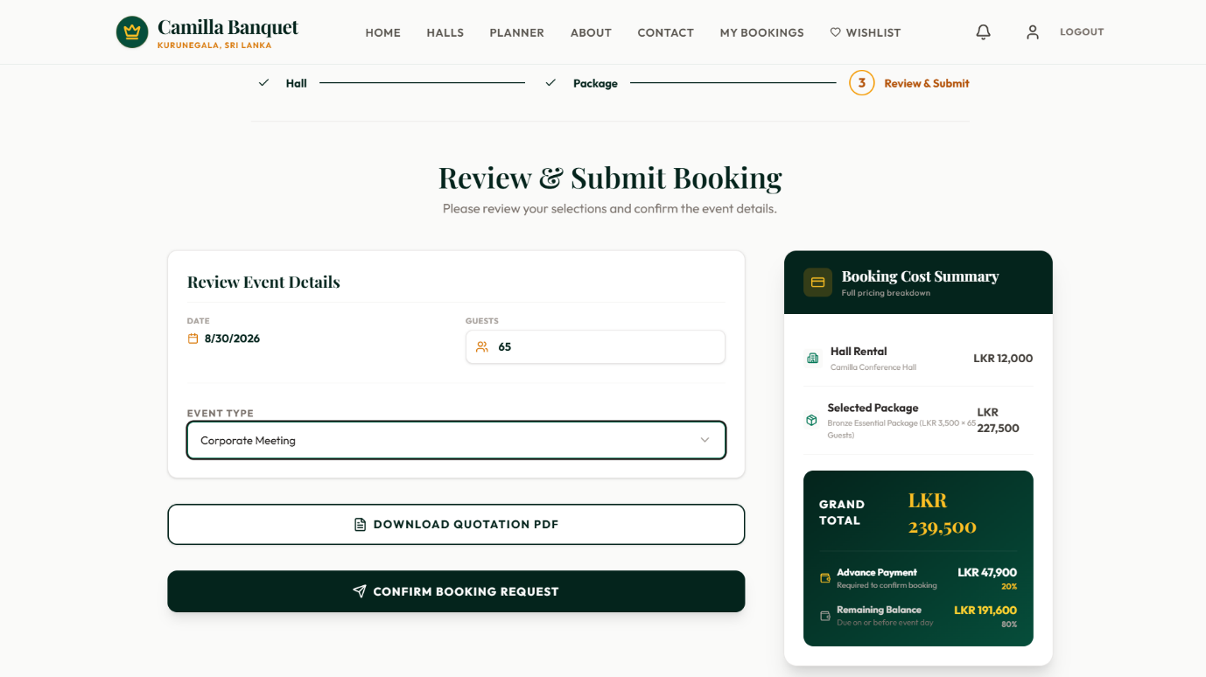
Figure 3. 12 : Booking Review & Checkout Page

The Booking Review & Checkout Interface provides customers with a final summary of their reservation before confirmation. It displays important booking details including selected hall, event date, guest count, package details, additional services, and the total cost.
Customers can select their preferred payment method, such as online payment through PayHere or manual cash payment. The system validates the booking information before submission to prevent incomplete or incorrect reservations.

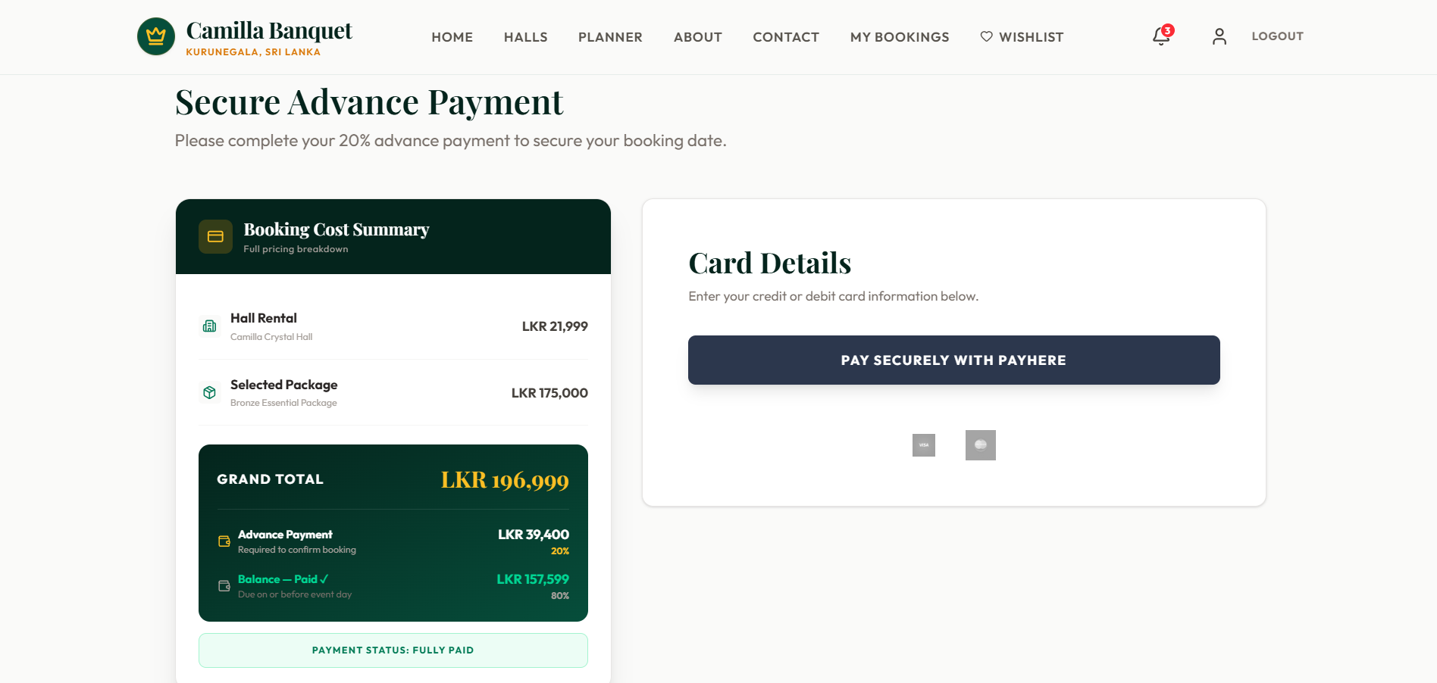
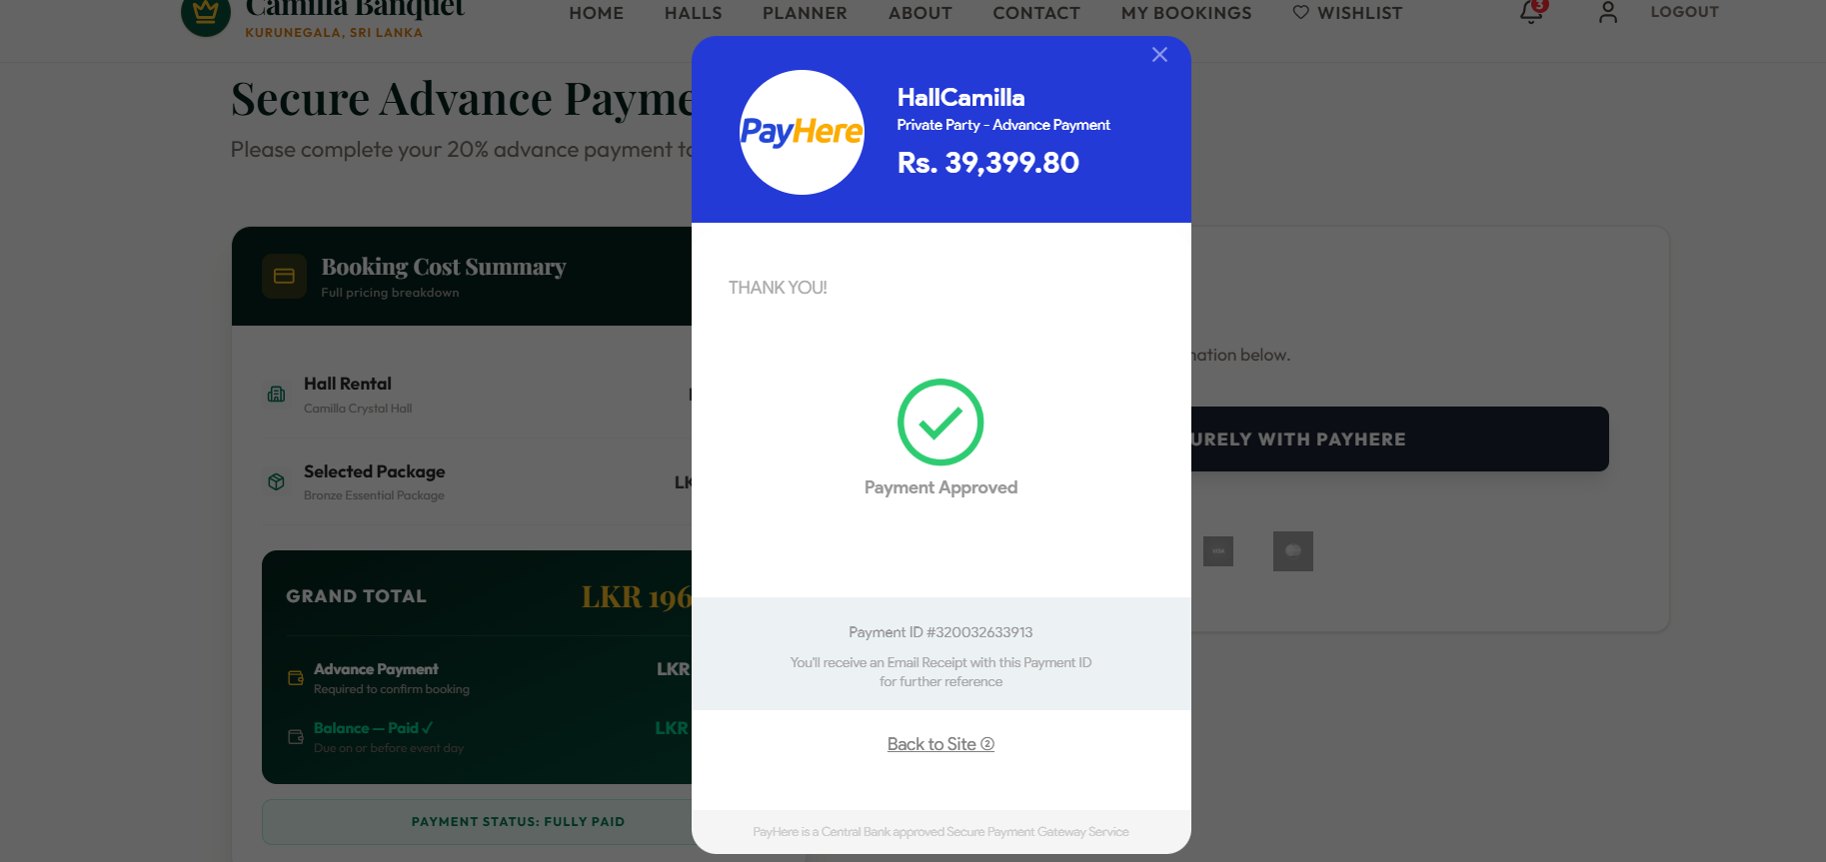
Figure 3. 13 : Payment Page

The Payment Interface enables customers to complete advance payments securely through the integrated PayHere payment gateway. It provides a simple payment screen where users can proceed with their selected payment option.
After successful payment verification, the system records the transaction details and creates the booking record in the Firebase Firestore bookings collection with the payment information.

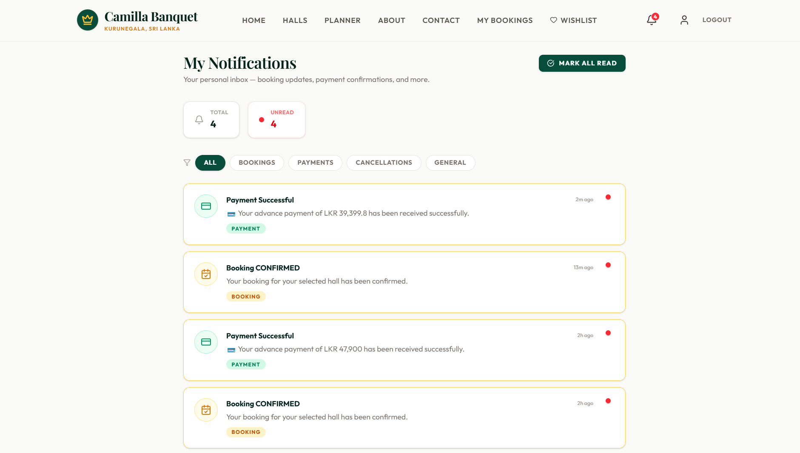
Figure 3. 14 : Customer Notifications Page

The Notifications Interface provides customers with a centralized location to view important system alerts and booking-related updates. It displays notifications in an organized list format, including details such as notification title, message preview, and timestamp.
The interface retrieves notification records from the Firebase Firestore notifications collection based on the logged-in user's ID. Customers can view updates such as booking approvals, payment confirmations, and reservation status changes directly within the system.
This feature ensures that customers do not miss important information, even if they do not access external email notifications, while improving communication between the system and users.

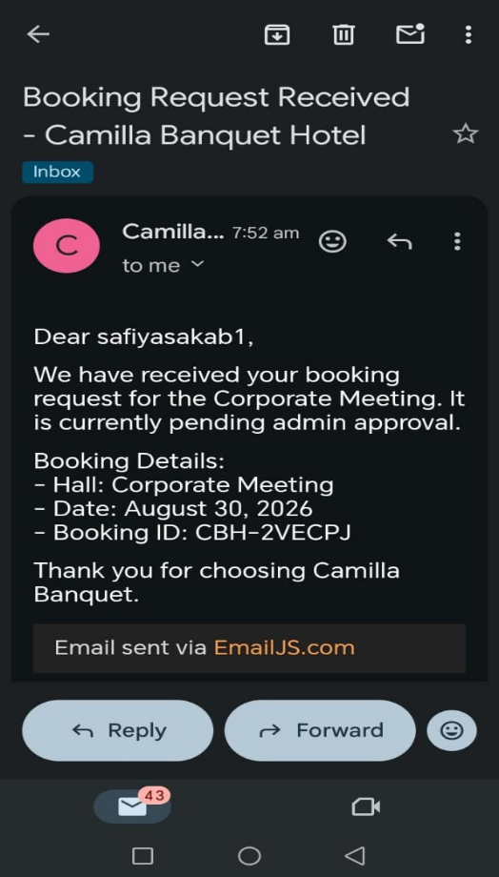

Figure 3. 15 : Automated Email Notification

The Automated Email Notification System uses EmailJS to send customers important updates such as booking confirmations, payment receipts, and booking status notifications. Each email includes relevant booking details and is sent to the customer's registered email address, providing a reliable record of their reservation and transactions.

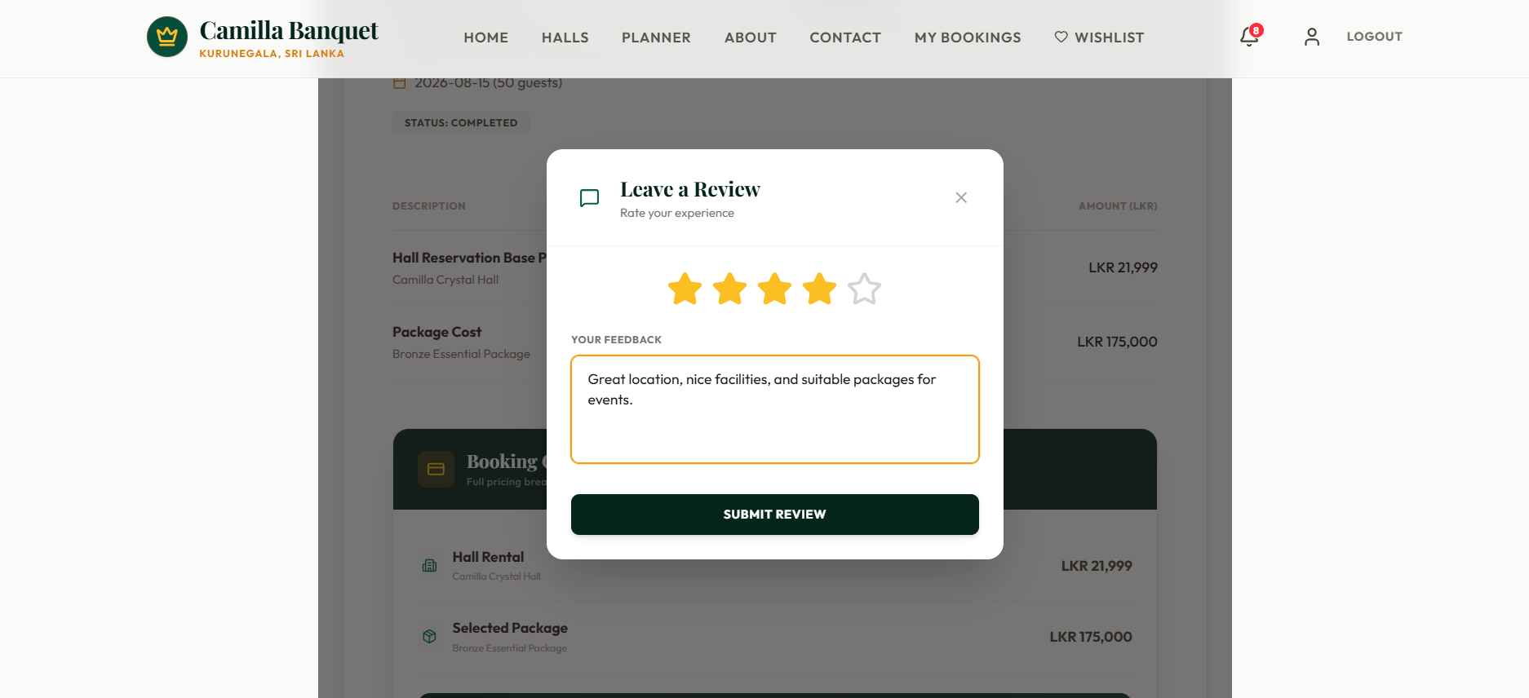
Figure 3. 16 : Customer Review Page

The Reviews Interface allows customers to share their experience after completing an event booking. Customers can provide feedback by selecting a star rating from 1 to 5 and entering comments about their experience.
The submitted reviews are stored in the Firebase Firestore reviews collection and linked with the customer's completed booking. New reviews are initially kept unpublished and require administrator approval before being displayed publicly, ensuring reliable and moderated feedback.

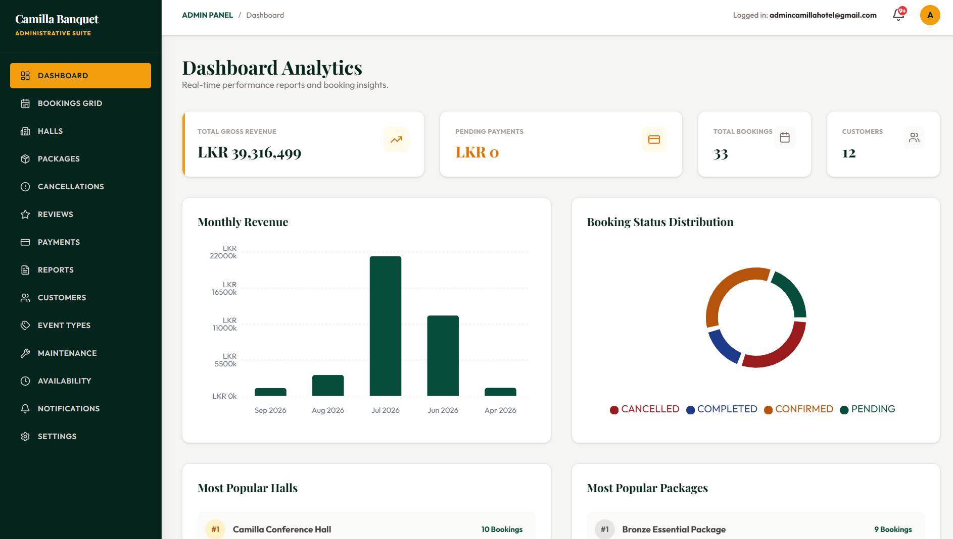
Figure 3. 17 : Admin Dashboard Page

The Admin Dashboard Interface acts as the central management area for administrators to monitor the overall performance of the hall booking system. It provides a visual overview of important business information through summary cards and analytical charts.
The dashboard displays key metrics such as total bookings, total revenue, and pending approvals. It uses graphical components to represent revenue trends and package popularity, helping administrators understand business performance easily.
The interface retrieves booking data from the Firebase Firestore bookings collection and processes information such as booking status and total prices to generate real-time reports. This helps administrators make informed decisions and efficiently manage daily operations.

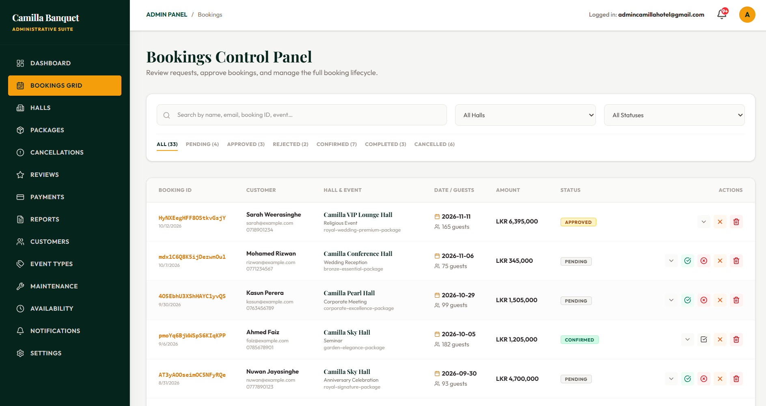
Figure 3. 18 : Booking Management Page

The Booking Management Interface allows administrators to efficiently manage customer reservations within the system. It provides a structured data table where administrators can view booking details, search records, and filter reservations based on their status, such as Pending, Approved, and Cancelled.
The interface retrieves booking information from the Firebase Firestore bookings collection and allows administrators to review and update reservation statuses through available actions. This replaces manual booking management methods with a centralized digital system, helping administrators process requests efficiently and avoid missed reservations.

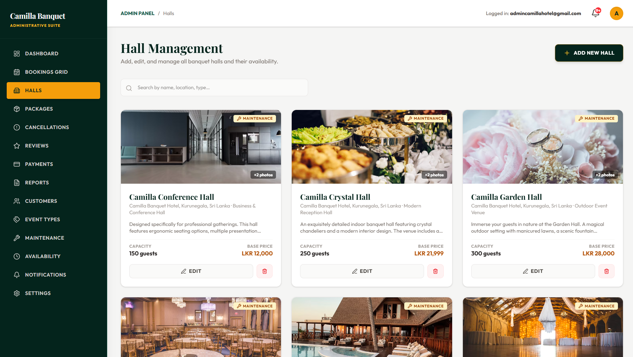
Figure 3. 19 : Hall Management Page

The Hall Details Management Interface allows administrators to manage and update detailed information about individual halls. It provides input fields for hall name, capacity, description, images, and other relevant details.
The interface includes form validation to ensure accurate data entry before saving changes. Updated information is stored in the Firebase Firestore halls collection and is automatically reflected in customer-facing interfaces such as the Hall Catalog and Hall Details pages.
This feature helps administrators maintain accurate hall information and keep the system content up to date.

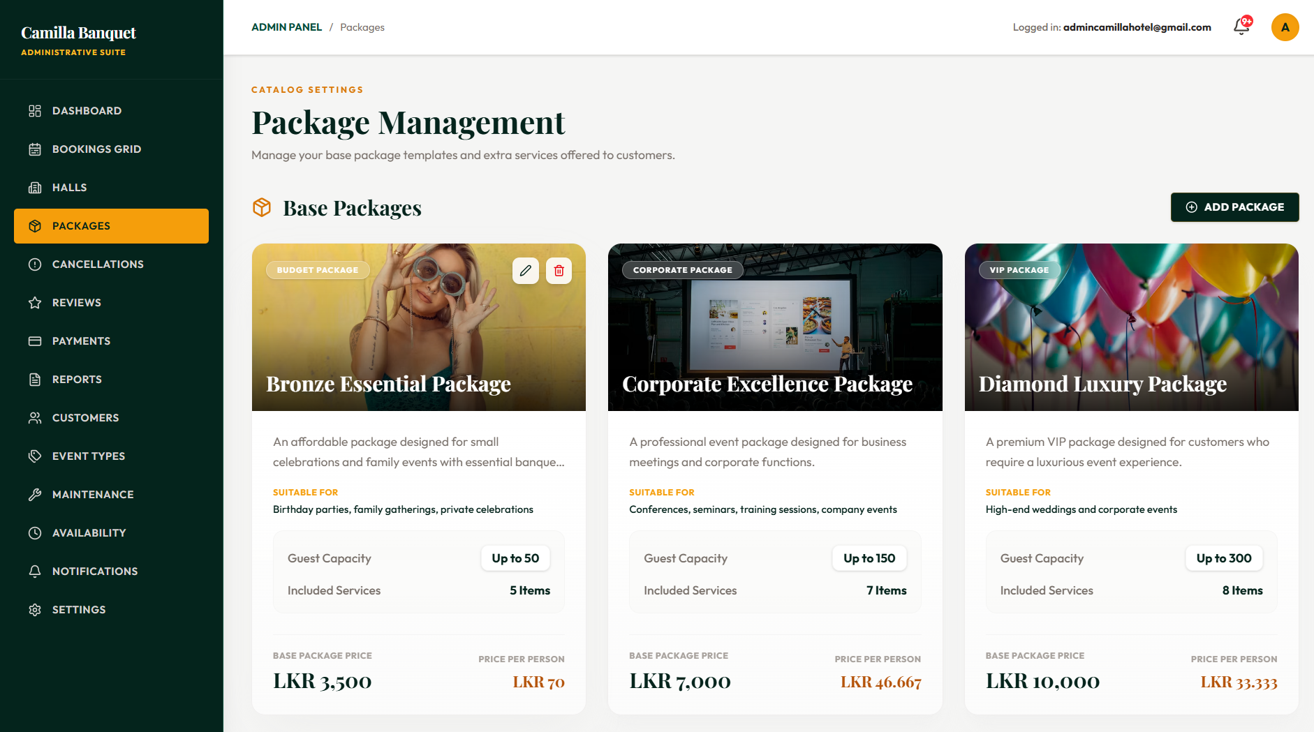
Figure 3. 20 : Package Management Page

The Package Management Interface allows administrators to create, update, and manage event packages offered by the venue. It provides a structured form for defining package details such as package name, category, guest limit, base price, extra guest charges, and included services.
The interface performs CRUD (Create, Read, Update, Delete) operations on the Firebase Firestore packages collection. Any changes made to package information, pricing, or included services are automatically reflected in the customer booking portal without requiring application updates.
This feature enables administrators to efficiently manage package offerings, adjust pricing, and introduce new event packages while ensuring customers always view the latest information.

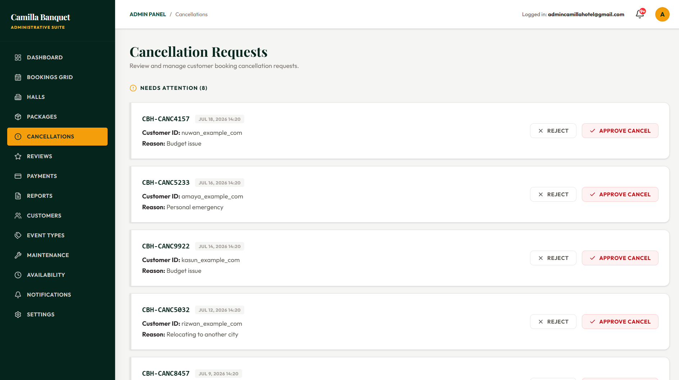
Figure 3. 21 : Booking Cancellation Page

The Cancellation Management Interface allows administrators to manage and cancel existing bookings when required. This functionality helps maintain accurate reservation records and ensures proper control over booking changes.
When an administrator selects the cancel option, the system displays a confirmation prompt to prevent accidental cancellations. After confirmation, the booking status is updated to "Cancelled" in the Firebase Firestore bookings collection.
Cancelled bookings are excluded from the availability checking process, allowing the selected date to become available for future reservations. This ensures that the booking calendar remains accurate and up to date.

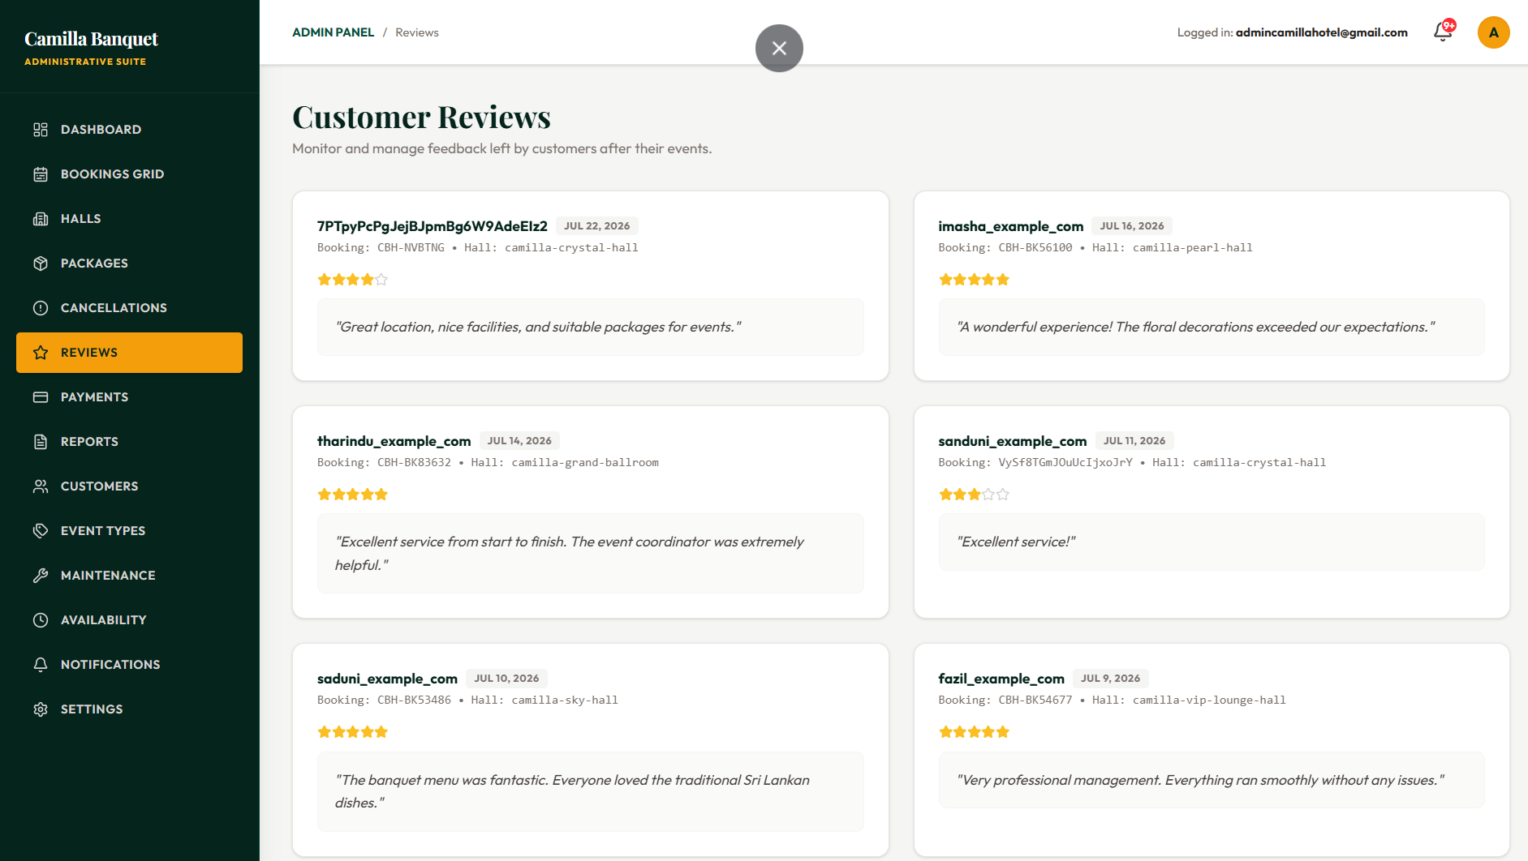
Figure 3. 22 : Review Management Page

The Reviews Management Interface allows administrators to review and control customer feedback before it appears publicly. It displays submitted reviews with details such as customer comments, star ratings, and publication status.
New reviews are stored with an unpublished status by default. Administrators can review the content and approve or reject reviews by changing the publication status. Only approved reviews are displayed on the customer-facing pages, ensuring reliable and appropriate feedback is shown publicly.
This feature helps administrators maintain the quality of customer reviews and protect the business reputation.

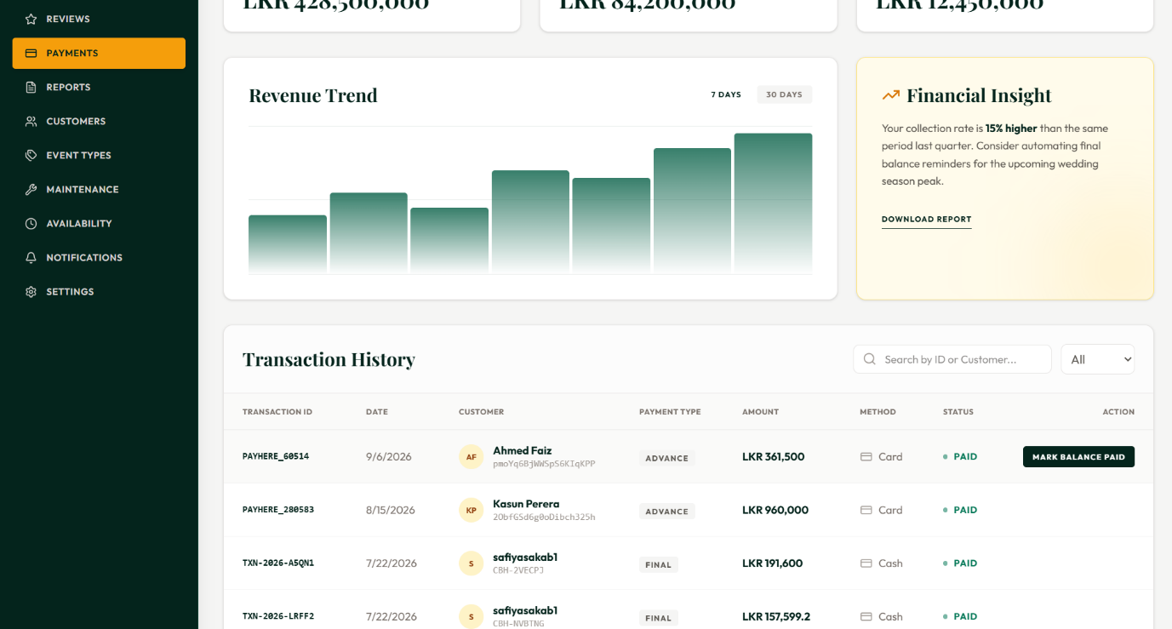
Figure 3. 23 : Payment Management Page

The Payment Management Interface allows administrators to monitor and manage customer payment records within the system. It separates bookings based on their payment status, helping administrators identify completed payments and pending transactions.
The interface highlights unpaid bookings, such as cash or bank transfer payments, and provides a "Mark as Paid" option to update the payment status after receiving payment. These updates are stored in the Firebase Firestore bookings collection, ensuring accurate financial records.
This feature helps administrators track outstanding payments efficiently and reduces dependency on manual payment records.
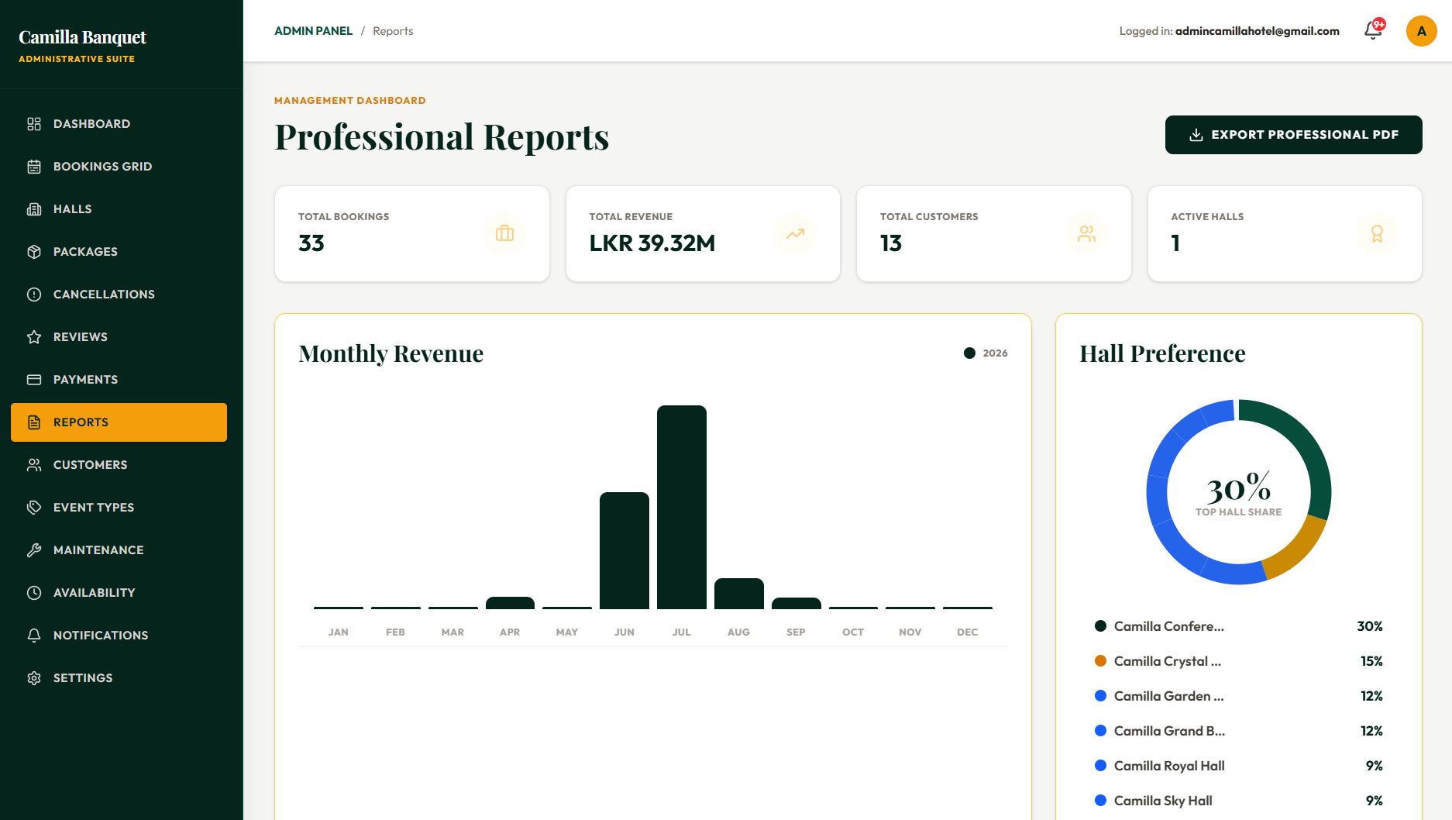
Figure 3. 24 : Reports & Analytics Page

The Reports & Analytics Interface allows administrators to generate professional reports for monitoring business performance and operational activities. It provides a date range selection option where administrators can specify the required reporting period.
When generating a report, the system retrieves relevant booking data from the Firebase Firestore bookings collection and processes the information into a structured format. Using jsPDF and jsPDF-AutoTable libraries, the system creates a downloadable PDF report containing important booking and financial details.
This feature reduces manual report preparation and helps administrators efficiently analyze booking activities, revenue information, and business performance.

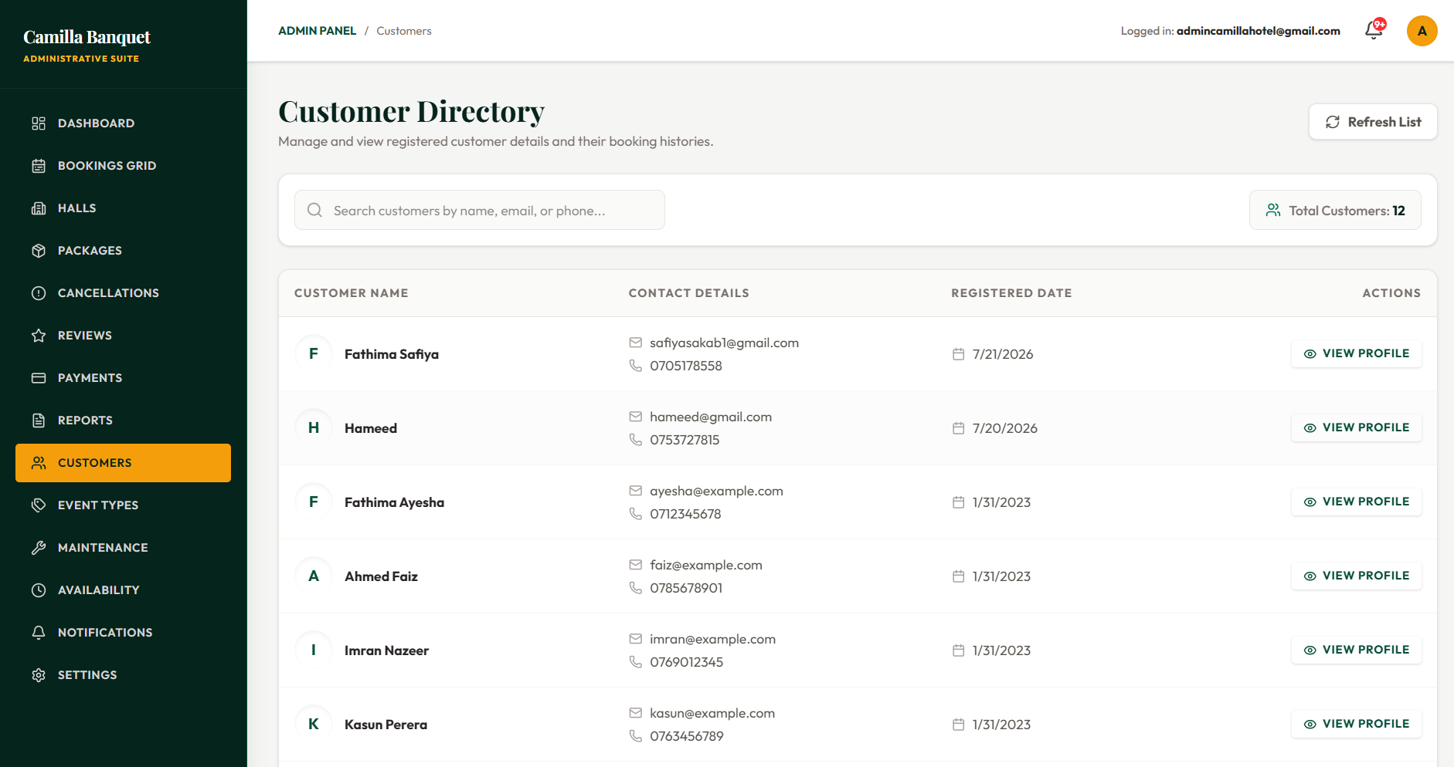
Figure 3. 25 : Customer Management Page

The Customer Management Interface provides administrators with a centralized view of all registered customers and their basic account information. It displays customer details such as name, email address, and phone number in an organized data table.
The interface retrieves customer records from the Firebase Firestore users collection and filters accounts based on the Customer role. A search feature allows administrators to quickly find specific customer profiles when required.
This feature helps administrators manage customer information efficiently and provides quick access to client details for handling booking-related assistance and support requests.

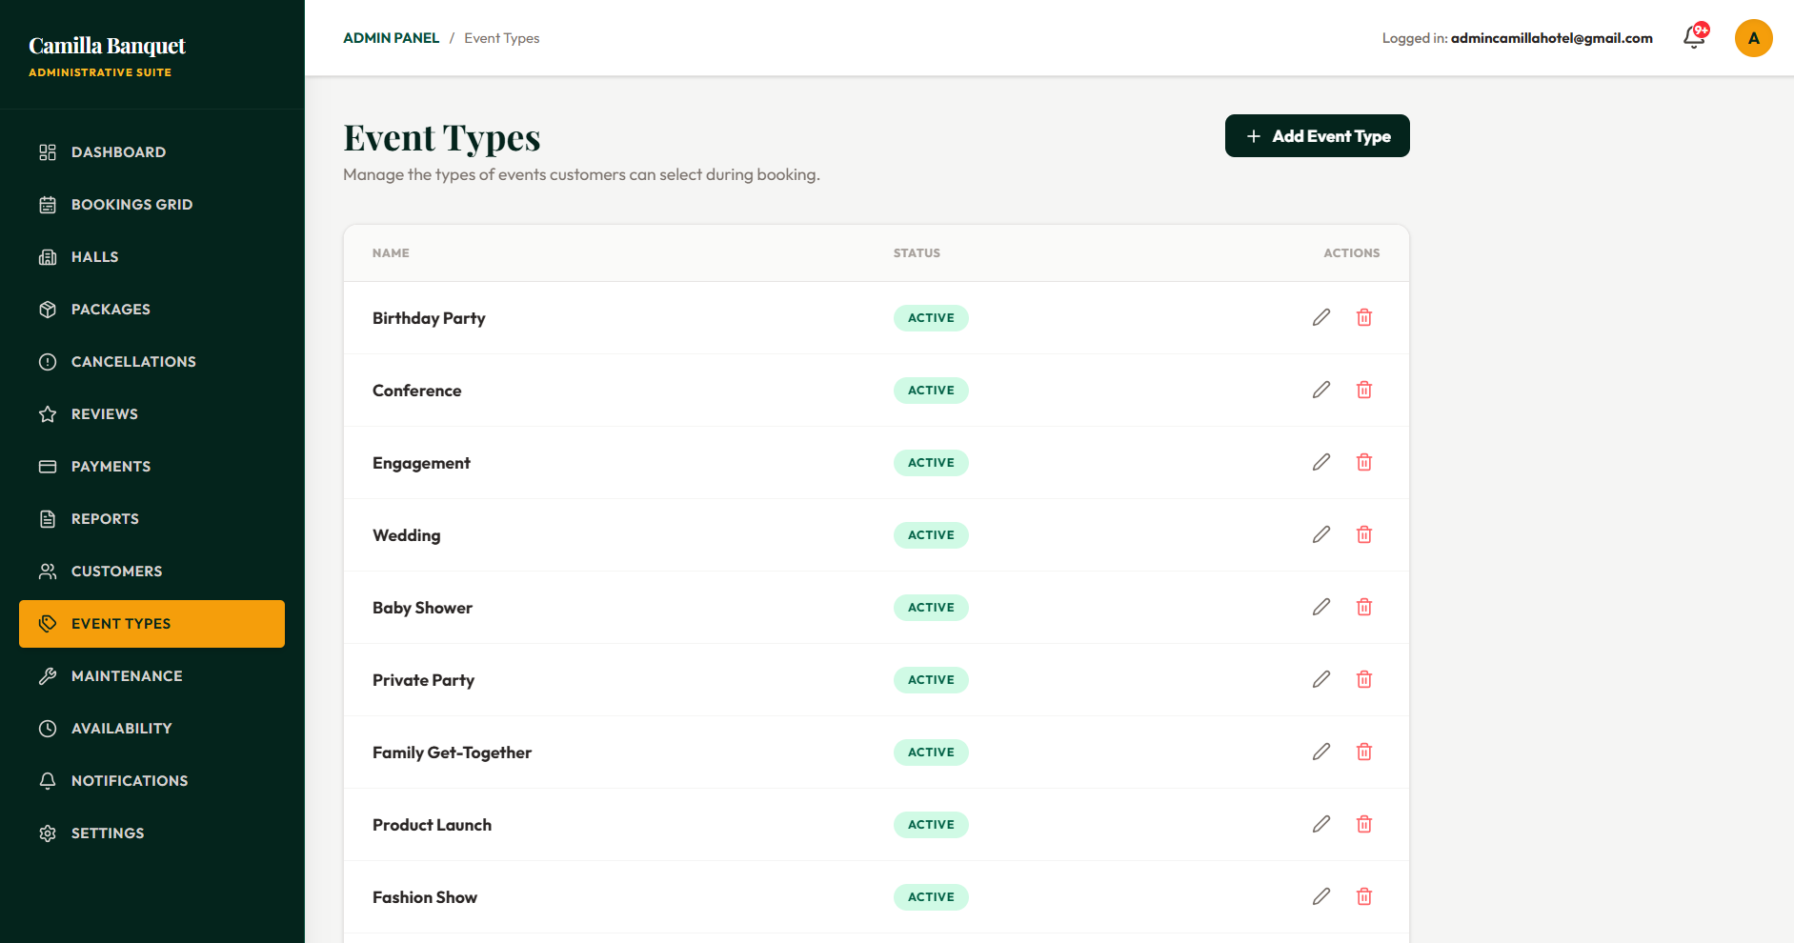
Figure 3. 26 : Event Types Management Page

The Event Types Management Interface allows administrators to manage available event categories such as weddings, corporate events, and birthday parties. Administrators can add, edit, activate, or deactivate event types through this interface.
The data is stored in the Firebase Firestore eventTypes collection, and changes are automatically reflected in the customer booking process. This feature provides flexibility by allowing event categories to be updated without modifying the application code.

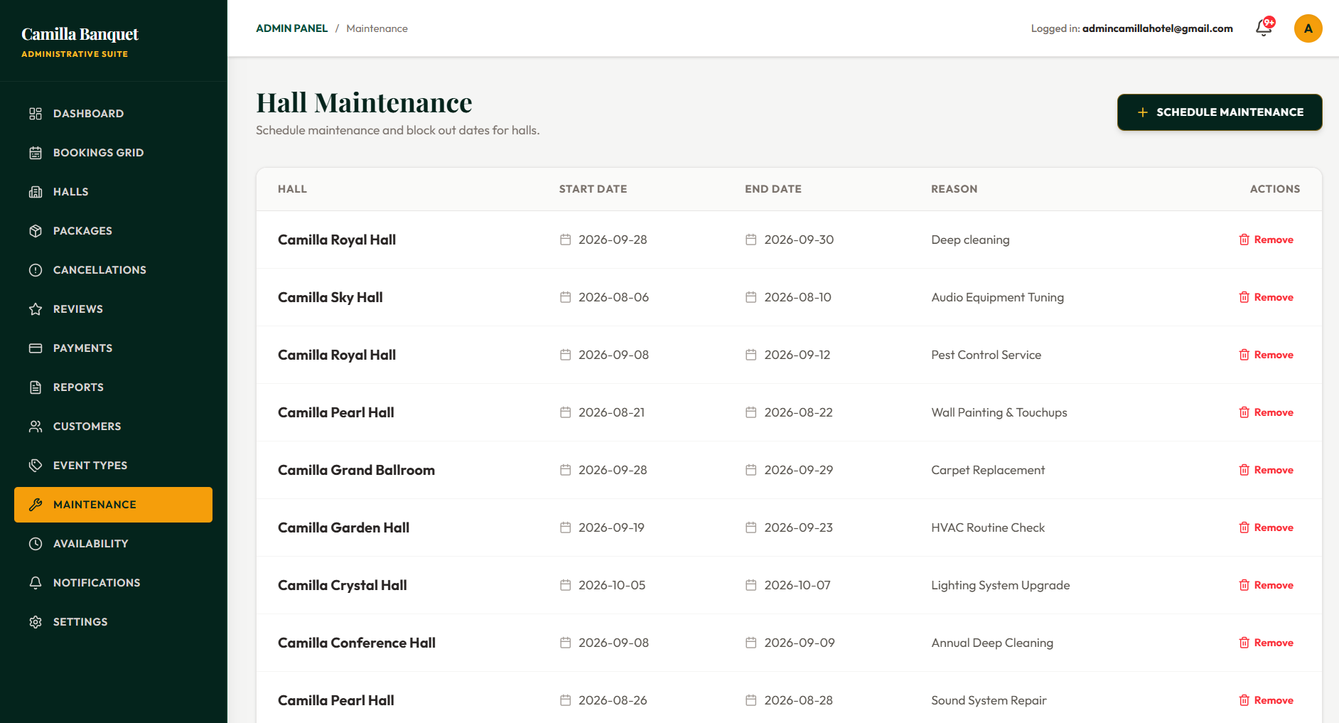
Figure 3. 27 : Hall Maintenance Page

The Hall Maintenance Interface allows administrators to block unavailable dates due to repairs, private events, or temporary closures. Administrators can enter a maintenance reason along with the required start and end dates.
The maintenance records are stored in the Firebase Firestore maintenance collection and are considered during the booking availability check. This prevents customers from reserving halls during unavailable periods and helps maintain accurate scheduling.

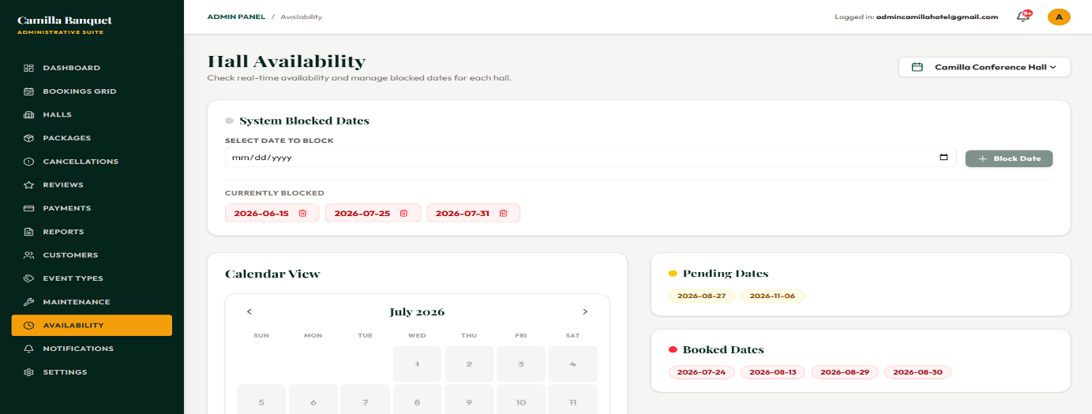
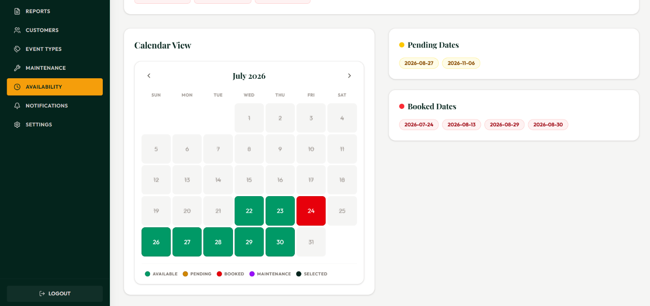
Figure 3. 28 : Availability Management Page

The Availability Management Interface provides administrators with a calendar-based view of hall schedules and bookings. It displays approved reservations as calendar events, allowing staff to quickly identify occupied and available dates.
The interface retrieves approved booking data from the Firebase Firestore bookings collection and presents it visually. This helps administrators manage venue capacity, verify availability, and handle customer inquiries efficiently.

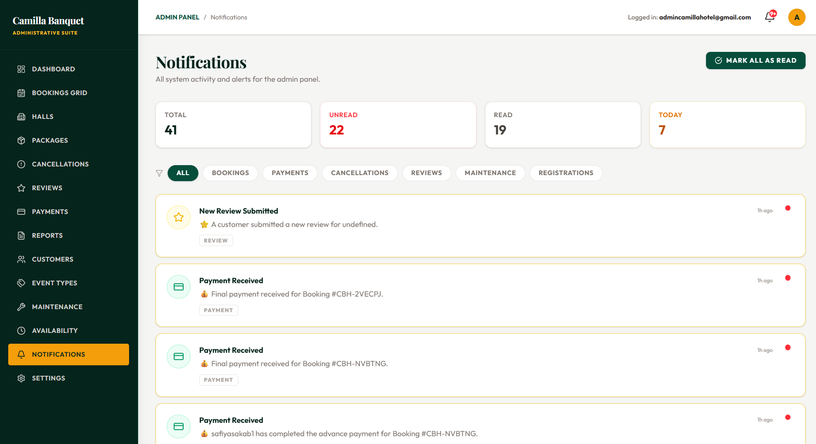
Figure 3. 29 : Notifications Management Page

The Notifications Management Interface allows administrators to monitor system-generated communications and maintain an activity record. It displays notification details such as recipient, message subject, and sent time.
The interface retrieves notification records from the Firebase Firestore notifications collection and provides a history of alerts and emails sent through the system. This helps administrators verify communication activities and handle customer inquiries effectively.

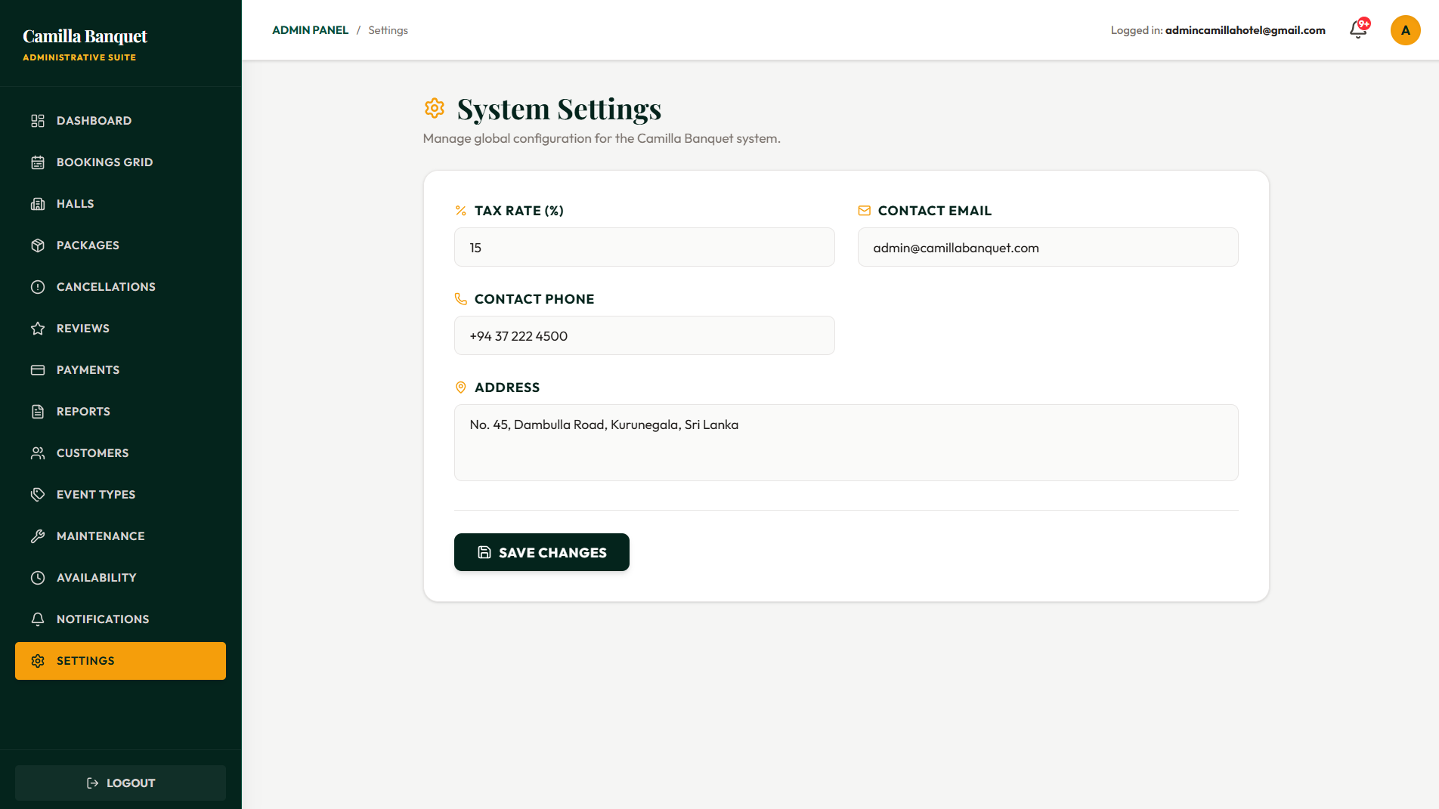
Figure 3. 30 : Admin Settings Page

The Settings Interface allows administrators to manage system preferences and account security details. It provides options to update administrative passwords and modify important venue information displayed across the system.
Password updates are securely handled through the Firebase Authentication service, ensuring that administrator accounts remain protected. This interface helps maintain system security and configuration management.

3.2 Database Design

HallCamilla utilizes Google Firebase Cloud Firestore, a scalable real-time NoSQL document database used for storing and synchronizing application data. Unlike traditional relational databases, Firestore stores information using Collections and Documents instead of tables and rows. However, the system maintains relational data consistency by using Document IDs and Reference IDs to establish logical relationships between different collections.
The database structure is designed to support hall management, customer reservations, payments, reviews, and administrative operations. The schema consists of the following main collections:
- Users – The central identity management collection that stores customer and administrator information. It contains fields such as uid (linked with Firebase Authentication), email, name, phone, role (Admin/Customer), and createdAt.
- Halls – Represents the available banquet halls within the system. It stores hall-related information including id, name, description, capacity, price, status, and imageUrls.
- Packages – Stores predefined event packages such as Silver, Gold, and Platinum. Each package contains details including id, hallId, packageName, packagePrice, guestLimit, extraGuestCharge, and includedServices.
- Bookings – The main transactional collection that records customer reservations. It stores booking information such as id, userId, hallId, packageId, eventDate, guestCount, totalAmount, bookingStatus (Pending, Approved, Confirmed, Completed, Cancelled), and paymentStatus.
- Payments – Maintains financial transaction records associated with bookings. It stores details including id, bookingId, userId, amount, paymentType (Advance/Final Balance), status, and date.
- Services – Stores optional additional services available for customers, such as photography, catering, and DJ services. It includes id, serviceName, description, price, pricingModel (Fixed/Per Person), and image.
- Reviews – Stores customer feedback and ratings related to completed events. It contains id, userId, hallId, bookingId, rating, comment, and createdAt.
- CancellationRequests – Manages customer booking cancellation requests and their approval workflow. It stores id, bookingId, userId, reason, status (Pending, Approved, Rejected), and requestDate.
- Maintenances – Stores hall maintenance schedules and blocked dates to prevent bookings during unavailable periods. It contains id, hallId, description, startDate, endDate, and status.
- EventTypes – Dynamically stores available event categories such as Wedding, Corporate Events, and Birthday Functions. It includes id, name, and isActive fields.
In this architecture, Users and Halls act as the primary parent entities. The Bookings collection functions as the central connection point, linking customers, halls, and packages together. Operational collections such as Payments, Reviews, and CancellationRequests store reference IDs such as userId, hallId, and bookingId to maintain relationships between documents.
Table 3.1 below summarizes the Document IDs (acting as Primary Keys), Reference IDs (acting as Foreign Keys), and relationship mapping between Firestore collections.
Table 3. 1 : Firestore Collection Structure and Relationship Mapping
Collection | Document ID (PK) | Reference ID (FK) | References | Relationship
Users | uid | — | — | Root/parent entity for customer and administrator identity
Halls | id | — | — | Root/parent entity for venue management
Packages | id | hallId | Halls.id | Many Packages → One Hall
Collection | Document ID (PK) | Reference ID (FK) | References | Relationship
Bookings | id | userId, hallId, packageId | Users.uid, Halls.id, Packages.id | Many Bookings → One User / One Hall / One Package
Payments | id | bookingId, userId | Bookings.id, Users.uid | Many Payments → One Booking
Reviews | id | userId, hallId, bookingId | Users.uid, Halls.id, Bookings.id | Many Reviews → One User / One Hall
CancellationRequests | id | bookingId, userId | Bookings.id, Users.uid | One Cancellation Request → One Booking
Maintenances | id | hallId | Halls.id | Many Maintenance Records → One Hall
Services | id | — | — | Independent entity used during booking customization
EventTypes | id | — | — | Independent entity used for event categorization

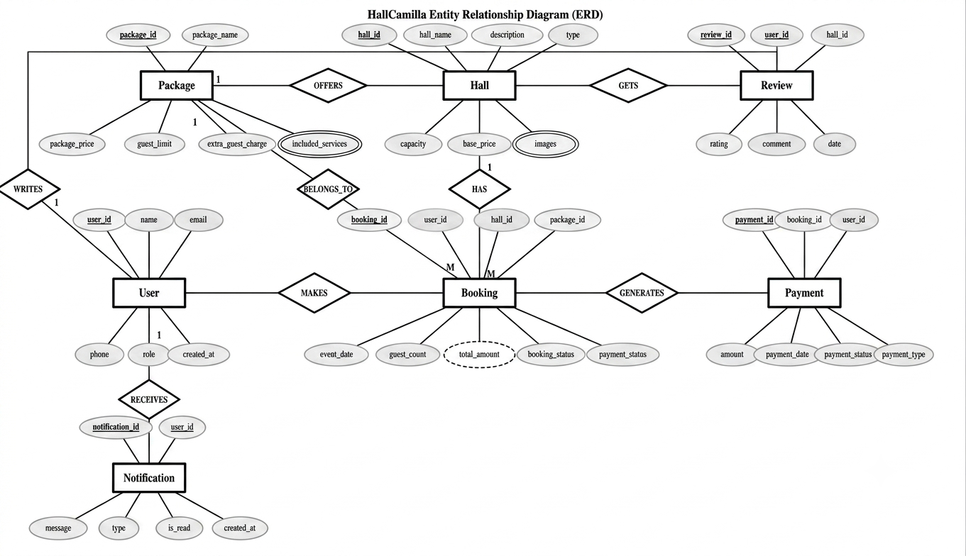
Figure 3. 31 : Entity Relationship Diagram

The Entity Relationship Diagram (ERD) illustrates the logical relationships between the main entities of the HallCamilla system. Although Firebase Cloud Firestore does not use traditional foreign key constraints like relational database management systems, the relationships between entities are maintained through reference fields stored within documents. These logical connections allow the system to efficiently retrieve and manage related data while supporting Firestore's flexible NoSQL architecture.
The User entity represents all registered customers and administrators in the system. A single user can create multiple bookings, receive various system notifications, and submit reviews after completed events. User information, including personal details and role information, is stored in the User collection, allowing the system to provide role-based access and personalized services.
The Hall entity stores information about the banquet halls available for reservation. Each hall can have multiple bookings over different dates and can offer several event packages. The Package entity contains predefined service packages that customers can select during the booking process. Each package includes information such as the package name, description, price, and included services, allowing administrators to manage package details independently.
The Booking entity is the central component of the system, linking customers, halls, and packages together. Each booking stores important information such as the selected hall, package, event date, guest count, booking status, payment status, and the automatically calculated total amount. Separating booking status from payment status allows the system to accurately manage booking progress and payment completion as two independent processes.
The Payment entity records all payment transactions associated with bookings. Each payment includes details such as the booking reference, payment amount, payment date, payment method, and payment type. Payments may be completed through the PayHere Sandbox payment gateway or recorded manually as cash payments by administrators. Whenever a payment is recorded, the system updates the corresponding booking information to maintain accurate financial records.
The Notification entity manages all system-generated messages sent to customers and administrators. Notifications are automatically created when important events occur, such as booking approvals, payment confirmations, booking cancellations, or other system updates. Users can view these notifications through the application and mark them as read when necessary.
The Review entity stores customer feedback submitted after completed events. Each review is associated with both a user and a hall, allowing customers to rate their experience and provide comments. These reviews help future customers make informed decisions while providing valuable feedback for administrators to improve their services.
Overall, the relationships between these entities form the foundation of the HallCamilla system. By maintaining logical references between collections, the system efficiently manages bookings, payments, notifications, and customer interactions while ensuring data consistency, reducing duplication, and supporting the smooth operation of the hall booking process.

3.3 Architectural Design

HallCamilla follows a modern, serverless client architecture, sometimes described as a decoupled frontend combined with a Backend-as-a-Service (BaaS) model, rather than the traditional pattern of a custom-built backend server communicating with a separate database. This architectural choice was made deliberately, since it allowed the project's development effort to be concentrated on the business logic and user experience of the booking and payment workflow, instead of being spent on building, securing, and hosting a custom API server from scratch.
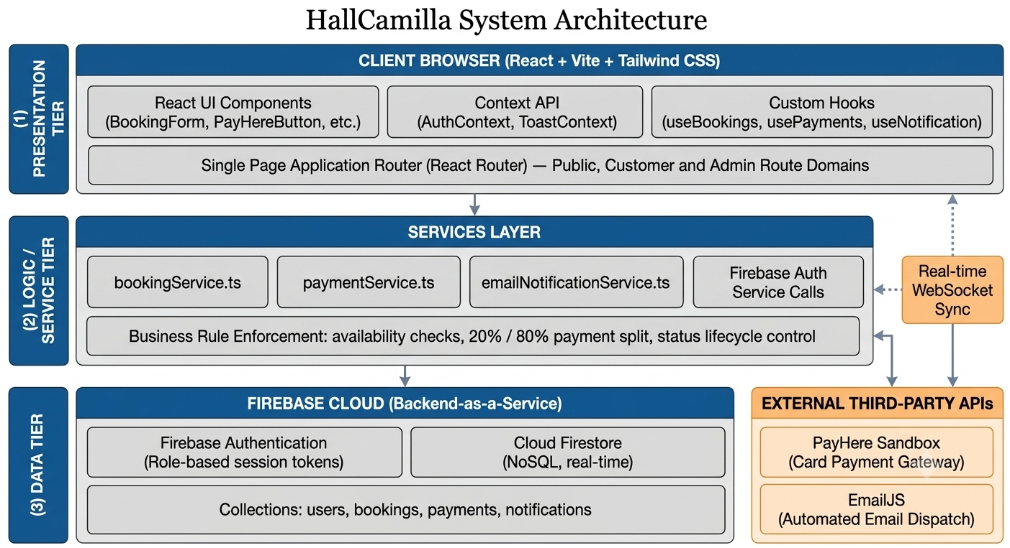
Figure 3. 32 : System Architecture Diagram

The architecture diagram above divides the system into three logical tiers. The Presentation Tier represents everything that runs inside the customer's or administrator's web browser, including the React user interface components such as the booking form and the PayHere payment button, the global Context API providers that hold shared state such as the currently authenticated user, and the custom hooks that expose live database subscriptions to the rest of the interface.
Beneath this sits the Logic and Service Tier, which contains dedicated service files such as bookingService.ts, paymentService.ts, and emailNotificationService.ts. This tier is deliberately placed between the user interface and the backend so that important business rules, including availability checking, the twenty and eighty percent payment split, booking status lifecycle management, and notification generation, are handled consistently in one central location rather than being scattered across individual React components.
Finally, the Data Tier represents the Firebase cloud infrastructure itself, consisting of Firebase Authentication, which verifies user identity and access roles, and Cloud Firestore, which stores and retrieves all application data. The diagram also shows how the Service Tier communicates with two external third-party services: EmailJS for sending automated email notifications and PayHere Sandbox for processing online card payments. It also illustrates the real-time WebSocket connection maintained by Firestore with the Presentation Tier, which allows changes such as administrator booking approval actions to appear on the customer's dashboard immediately without requiring a manual browser refresh.
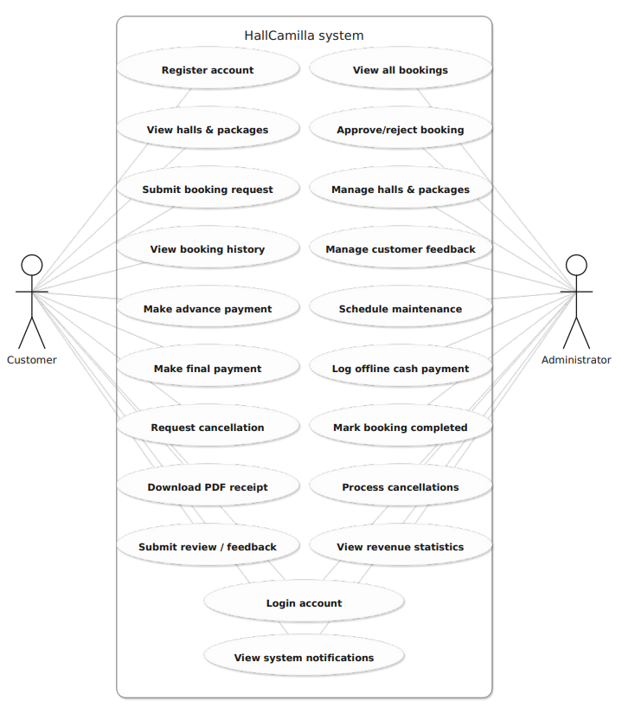
Figure 3. 33 : Use Case Diagram

The use case diagram illustrates the two main actors who interact with HallCamilla and the specific operations each actor can perform within the system boundary. There is no unauthenticated guest actor shown in the diagram because HallCamilla requires users to authenticate before accessing dashboards or submitting booking requests. This ensures that all meaningful actions within the system are connected to a specific user account.
The Customer actor is shown on the left side of the diagram and is connected to use cases such as registering an account, submitting a booking request, making advance or final payments, requesting booking cancellations, and downloading PDF receipts of completed transactions. The Administrator actor is shown on the right side and is connected to use cases such as approving or rejecting booking requests, recording offline cash payments, marking bookings as completed, and viewing revenue statistics through the payment dashboard.
Several use cases, including user authentication and notification viewing, are shared between both actors because customers and administrators must log into the system and both receive their own category of real-time notifications.

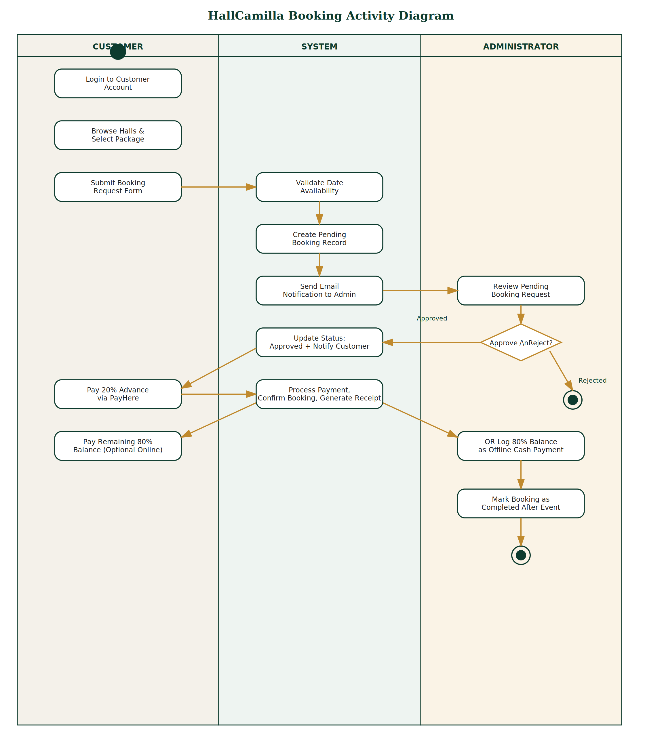
Figure 3. 34 : Activity Diagram
The activity diagram traces the complete lifecycle of a single booking from the moment a customer logs into the system until the event is completed. The process is organised into three swimlanes representing the Customer, System, and Administrator respectively.
The flow begins in the Customer lane, where the user logs in, browses available halls and packages, and submits a booking request. Control then moves into the System lane, where the request is validated against existing reservations for the selected date, a new document is created in the bookings collection with a Pending status, and an email notification is automatically sent to the hotel administrator.
The process then moves into the Administrator lane, where the booking request is reviewed and a decision is made at the Approve or Reject decision point. A rejected request ends the process at that stage, while an approved request causes the System lane to update the booking status and notify the customer. Control then returns to the Customer lane, where the user completes the twenty percent advance payment through PayHere. The System processes the transaction, updates the payment information, confirms the booking, and generates a payment receipt.
Later in the timeline, the remaining eighty percent balance payment can either be completed online by the customer or recorded as an offline cash payment by the administrator. Finally, the administrator marks the booking as Completed once the event has taken place, after which the customer can log back into their dashboard to submit a post-event review rating their experience.

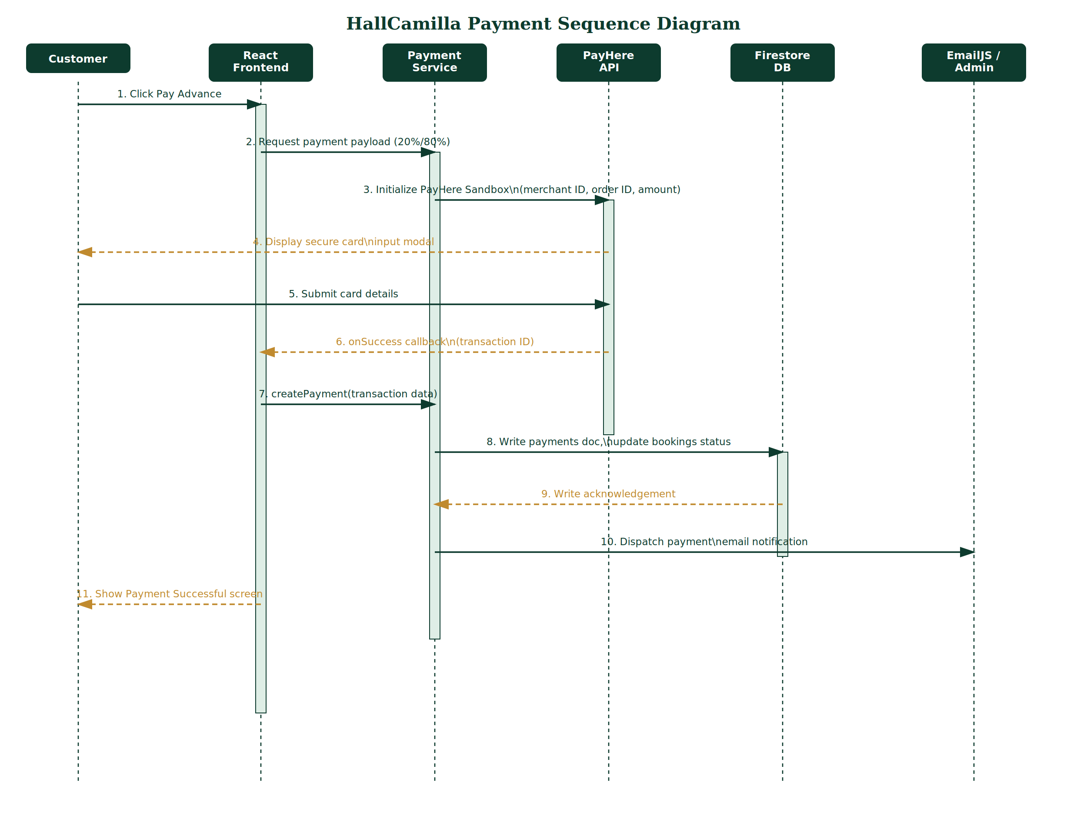
Figure 3. 35 : Sequence Diagram

The sequence diagram focuses specifically on the hybrid online payment process, as this is the most technically involved interaction in the system and the process that depends most heavily on communication with an external third-party service.
Reading the diagram from top to bottom, the process begins when the Customer clicks the Pay Online button inside the React Frontend. The frontend then communicates with the Payment Service to calculate the correct payment amount for either the twenty percent advance payment or the eighty percent final balance payment, depending on the current stage of the booking.
The Payment Service initializes the PayHere Sandbox payment widget using required details such as the merchant identifier, order identifier, and calculated payment amount. At this point, PayHere takes control and displays its secure payment interface directly to the customer. After the customer completes the card payment, PayHere returns an asynchronous success callback to the React Frontend containing transaction information. This response is represented using a dashed arrow in the sequence diagram because it represents a returned result rather than a new request.
The frontend then calls the Payment Service's createPayment function, which creates a new document in the payments collection within Firestore and updates the related booking document with the latest payment status. After Firestore confirms the successful database update, the Payment Service triggers an automated email notification through EmailJS to inform the hotel administrator about the received payment.
At the same time, the React Frontend displays the payment success confirmation message to the customer, completing the advance payment workflow.

CHAPTER 4 : IMPLEMENTATION

4.1 Development Approach

The development of the HallCamilla system followed an Agile Incremental development approach, where the system was developed through short iterative cycles. Each iteration focused on implementing and testing a specific functional module before proceeding to the next stage.
The development process began with the implementation of Firebase Authentication and Firestore database design, as these components provided the foundation required for user management, role handling, and data storage. After establishing the core structure, major functionalities such as hall management, booking processing, payment integration, and notification services were implemented incrementally.
Version control was managed using Git and GitHub, allowing changes to be tracked throughout the development process. The frontend application was continuously deployed using Firebase Hosting, enabling frequent testing of newly implemented features in a live environment.

4.2 Implementation of Key Modules

- Authentication and Role Management
Authentication was implemented using Firebase Authentication with email and password-based login. Since Firebase Authentication does not provide built-in role management, a separate user document was created in the Firestore users collection during registration.
The user document stores additional information such as user details and role information (Customer/Admin). This role-based structure allows the React Router protection system to control access to different areas of the application, ensuring customers and administrators are directed to their respective interfaces.
- Booking Management
The Booking Management module was implemented using a multi-step booking workflow that allows customers to select a hall, package, guest count, event date, and additional services.
Before creating a booking record, the system performs availability validation by checking existing bookings stored in the Firestore bookings collection. This prevents multiple customers from reserving the same hall for the same date.
The final booking amount is calculated dynamically based on selected package pricing, guest count, and additional service charges. The calculated value is stored with the booking record for future reference.
- Payment Processing
The payment module was integrated using the PayHere Sandbox payment gateway to support online advance payments. The system calculates the required payment amount based on the booking payment rules and sends the payment details securely to the PayHere payment interface.
After successful payment confirmation, the system records the transaction details in the payments collection and updates the related booking payment status. Manual cash payments processed by administrators follow the same database structure to maintain consistent financial records.
- Automated Email Notifications
Automated notifications were implemented using EmailJS to provide booking and payment-related communication between the system and users.
When important actions occur, such as booking submission, approval, or successful payment completion, the system triggers an email notification to the relevant users. This approach provides automated communication without requiring a dedicated email server.
- Real-Time Dashboard Updates
The system utilizes Firestore real-time listeners through the onSnapshot() method to provide live data updates. When administrators modify booking statuses, changes are automatically reflected in the customer interface without requiring manual page refreshes.
This real-time functionality improves user experience by ensuring that customers and administrators always view the latest booking information.

4.3 Challenges Faced

- Preventing Double Bookings
Since Firestore does not provide SQL-style unique constraints, preventing duplicate hall reservations required implementing a custom availability validation mechanism.
The system checks existing bookings before creating a new reservation and verifies whether the selected hall is already reserved for the requested date.
- Managing Payment Status Flow
Handling different payment stages was challenging because the system needed to distinguish between booking approval, advance payment, and final payment completion.
To overcome this issue, separate fields were maintained for bookingStatus and paymentStatus. This ensured that payment updates did not incorrectly change the overall booking lifecycle.
- Securing Administrative Routes
Since the application uses a client-side architecture, unauthorized users could attempt to access administrative routes directly.
A protected routing mechanism was implemented using a custom ProtectedRoute component, which verifies the authenticated user's role before granting access to administrative pages.
- Managing Development Time and Feature Prioritization
Developing a complete booking management system within the available time required careful prioritization of features.
The development sequence was planned by implementing essential components first, including authentication, database structure, booking workflow, and user interfaces. Advanced integrations such as payment processing and automated notifications were implemented after the core system functionality was completed.

CHAPTER 5 : TESTING

5.1 Testing Approach

Testing was performed throughout the development process rather than only at the final stage. Each implemented module was tested against its expected functionality to ensure reliability and correctness. Testing was conducted using the deployed Firebase Hosting environment to validate system behavior under realistic operating conditions.
The following three levels of testing were carried out:
Unit Testing
Individual system functions were tested independently, including booking cost calculations, advance payment calculations, and hall availability validation logic. This ensured that core business rules produced accurate results.
Integration Testing
Integration testing was performed to verify communication between different system components, including Firebase Authentication, Firestore database operations, PayHere Sandbox payment processing, and EmailJS notification services. Both successful and failed scenarios were tested to ensure proper error handling.
User Acceptance Testing (UAT)
Complete user workflows were tested from the customer's and administrator's perspectives. The testing process included user registration, login, browsing halls, package selection, booking submission, administrator approval, online payment processing, and submitting post-event reviews.

5.2 Test Cases

Table 5.1 presents a representative set of test cases covering the major functional requirements of the HallCamilla system.
Table 5 . 1 : Representative Test Cases
Test ID | Module | Test Description | Expected Result | Status
TC-01 | Authentication | Register with a valid email and password | Firebase authentication account is created, user profile is stored in Firestore, and user is redirected successfully | Pass
TC-02 | Authentication | Login using an incorrect password | System rejects access and displays an appropriate error message | Pass
TC-03 | Booking | Attempt to book an already reserved hall date | System prevents booking and displays an availability warning | Pass
TC-04 | Booking | Submit a booking request for an available date | Booking is stored with Pending status and notification is generated | Pass
TC-05 | Admin Panel | Administrator approves a pending booking | Booking status is updated and reflected immediately in the customer dashboard | Pass
TC-06 | Payment | Complete advance payment through PayHere Sandbox | Payment record is stored and booking payment status is updated successfully | Pass
TC-07 | Payment | Administrator records final cash payment | Payment record is updated and booking is marked as fully paid | Pass
Test ID | Module | Test Description | Expected Result | Status
TC-08 | Notifications | Change booking status from Pending to Approved | Customer receives an in-app notification about the status update | Pass
TC-09 | Security | Customer attempts to access admin URL | Protected route prevents access and redirects the user appropriately | Pass

5.3 User Acceptance Testing Summary

The complete customer and administrator workflows were successfully tested using the live Firebase environment. The main booking process, including registration, hall selection, booking submission, administrator approval, payment processing, and review submission, was verified successfully.
During testing, several minor issues were identified, including delays in real-time status updates and routing behavior for unauthorized users. These issues were analyzed, corrected, and retested before project completion.
After final testing, no critical errors or blocking issues remained. The completed HallCamilla system demonstrated stable functionality and satisfied the defined functional requirements.

CHAPTER 6 : RESULTS AND EVALUATION

6.1 Achievement of Objectives

- The objectives defined at the beginning of the project were successfully achieved, and the implemented features are fully functional within the deployed HallCamilla system.
- The project successfully developed a complete serverless web-based hall booking and management system using React, Vite, Tailwind CSS, Firebase Authentication, and Firestore, which has been deployed using Firebase Hosting.
- Customers are able to browse available halls, view package details and pricing information, calculate estimated event costs, and submit booking requests with real-time availability validation to prevent duplicate reservations.
- Administrators can manage the booking process through a real-time dashboard powered by Firestore listeners, allowing them to monitor, approve, or reject customer reservations without requiring manual page refreshes.
- The system successfully integrates the PayHere Sandbox payment gateway to support online advance payments while maintaining the required payment workflow of a 20% advance payment and 80% remaining balance.
- Automated email notifications are implemented using EmailJS, allowing customers and administrators to receive updates regarding booking confirmations, approvals, and payment-related activities.
- The system also provides a responsive user interface, enabling customers and administrators to access and manage the platform effectively across desktop and mobile devices.

6.2 Limitations

- Although the HallCamilla system achieved its main objectives, several limitations were identified due to the project scope and available development time.
- The PayHere payment integration currently operates in Sandbox mode. Although it successfully demonstrates the payment workflow, real-world transactions would require official merchant verification and production configuration.
- Email notifications are implemented using EmailJS, which provides a simple client-side communication solution. However, large-scale commercial usage may require migration to a dedicated email service such as SendGrid or Amazon SES to support higher email volumes.
- The current system does not include SMS notification functionality. Users receive important updates through the application notification system and email communication only.
- The payment workflow follows a fixed 20% advance and 80% final balance structure. Flexible installment plans, automated refunds, and advanced cancellation refund calculations are not currently supported and would require additional development.
- Testing was mainly performed manually during the development process. Although this was sufficient for an academic project, a commercial-level deployment would benefit from automated testing frameworks such as Jest or Cypress and a dedicated quality assurance process.
- The evaluation was mainly conducted by the developer and project supervisor. A larger user evaluation involving external customers and hotel staff would provide additional insights into usability and further improvements.

CHAPTER 7 : CONCLUSION AND FUTURE WORK

7.1 Conclusion

The HallCamilla system was developed to address the challenges associated with traditional manual hall booking processes, including difficulties in availability management, pricing transparency, and booking coordination. The proposed system provides a centralized digital platform that enables customers to explore halls, calculate event costs, submit reservations, and complete payments efficiently.
Throughout the development process, the main objectives of the project were successfully achieved. The final system includes secure user authentication, hall and package management, a multi-step booking workflow, PayHere payment integration, automated email notifications, customer dashboards, and real-time administrative monitoring.
The system was successfully implemented and deployed using Firebase Hosting with Cloud Firestore as the real-time database platform. The project demonstrated the importance of effective NoSQL database design, especially in areas such as preventing duplicate bookings through custom validation logic. Additionally, the use of Firestore real-time listeners improved the overall user experience by providing instant updates without requiring manual page refreshes.
Overall, HallCamilla provides a reliable and scalable solution for modernizing the hall booking process while improving operational efficiency for administrators and convenience for customers.

7.2 Future Work

Although HallCamilla successfully fulfills its current objectives, several improvements can be introduced in future development phases:
- Live Payment Gateway Integration
The current PayHere integration operates using Sandbox mode. Future improvements can include migrating to a production payment environment after completing official merchant registration, allowing real financial transactions.
- Dedicated Email Service Integration
The current EmailJS notification system can be enhanced by integrating a dedicated backend email service such as SendGrid or AWS SES to improve security, reliability, and scalability for larger communication volumes.
- SMS Notification System
An SMS notification feature can be introduced to provide customers with instant booking confirmations, approval updates, and payment reminders through mobile messages.
- Advanced Payment Management
Future versions can support flexible payment options, including customized installment plans, automated refund calculations, and improved cancellation payment workflows.
- Mobile Application Development
A dedicated mobile application can be developed for customers and administrators to provide easier access to booking management, notifications, and real-time updates.
- Automated Testing Framework
Future development can include automated testing tools such as Jest or Cypress to reduce manual testing efforts and improve system reliability as additional features are introduced.
These enhancements would extend HallCamilla from its current functional version into a more comprehensive hotel and event management platform capable of supporting larger-scale business operations.

APPENDICES

Appendix A: List of Abbreviations

Table A . 1 : Abbreviations Used in This Report
Abbreviation | Meaning
API | Application Programming Interface
CSS | Cascading Style Sheets
ERD | Entity Relationship Diagram
FK | Foreign Key
HNDIT | Higher National Diploma in Information Technology
IEEE | Institute of Electrical and Electronics Engineers
MVP | Minimum Viable Product
NoSQL | Not Only SQL
PDF | Portable Document Format
PK | Primary Key
SaaS | Software as a Service
SPA | Single Page Application
SRS | Software Requirements Specification
UAT | User Acceptance Testing
UI | User Interface
UX | User Experience

REFERENCES

- EmailJS. (n.d.). EmailJS Documentation. Retrieved July 14, 2026, from https://www.emailjs.com/docs/
- Git Project. (n.d.). Git Documentation. Retrieved July 14, 2026, from https://git-scm.com/doc
- Google. (n.d.). Firebase Documentation: Cloud Firestore and Firebase Authentication. Retrieved July 14, 2026, from https://firebase.google.com/docs
- Microsoft. (n.d.). Visual Studio Code Documentation. Retrieved July 14, 2026, from https://code.visualstudio.com/docs
- Node.js Foundation. (n.d.). Node.js Documentation. Retrieved July 14, 2026, from https://nodejs.org/docs/latest/api/
- npm, Inc. (n.d.). npm Documentation. Retrieved July 14, 2026, from https://docs.npmjs.com/
- Parallax. (n.d.). jsPDF Documentation. Retrieved July 14, 2026, from https://parall.ax/products/jspdf
- PayHere. (n.d.). PayHere Developer Documentation. Retrieved July 14, 2026, from https://support.payhere.lk/api-&-plugins
- React Core Team. (n.d.). React Documentation. Retrieved July 14, 2026, from https://react.dev/
- React Router Team. (n.d.). React Router Documentation. Retrieved July 14, 2026, from https://reactrouter.com/
- Tailwind Labs. (n.d.). Tailwind CSS Documentation. Retrieved July 14, 2026, from https://tailwindcss.com/docs
- TypeScript Team. (n.d.). TypeScript Documentation. Retrieved July 14, 2026, from https://www.typescriptlang.org/docs/
- Vite Team. (n.d.). Vite Documentation. Retrieved July 14, 2026, from https://vite.dev/

